Intermediate Virtualization

IaC for VMware with Ansible

Weight: 15% Marks: /100

Student Name:

Student ID:

Date:

This page was intentionally left blank.

Table of Contents

IaC For VMware with Ansible 1

Introduction 1

Equipment and Materials 1

Procedure 2

Part A: Prepare the VMware vSphere Environment 2

Part B: Install Ansible on a Linux Virtual Machine 5

Part C: Gather Information About VMware ESXi Hosts 7

Part C: Create a Virtual Machine from a Template 10

Part D: Configure the VM as a Web Server 11

Part E: Demonstrations 15

Part F: Submit Files 15

Marking Criteria 16

Resources 17

References 17

Appendix 18

Install Alpine Linux in ESXi 18

# IaC For VMware with Ansible

## Introduction

Red Hat Ansible is an open-source IT tool that automates resource provisioning, configuration management, continuous deployment and zero-downtime updates. It makes complex manual configuration repeatable and less susceptible to errors. In this lab, you’ll demonstrate vSphere management automation to your instructor, and then submit your code for marking.

## Equipment and Materials

* Windows computer with a minimum of 32 GB RAM and 250 GB free disk space, capable of nested virtualization
* VMware Workstation 17.x or later
* VMware ESXi 7.x or later
* VMware vCenter Server 7.x Standard or later
* Alpine Linux
* Red Hat Ansible core version 2.17 or later
* A Linux VM with Python 3 (version 3.8 and higher) as the control node.

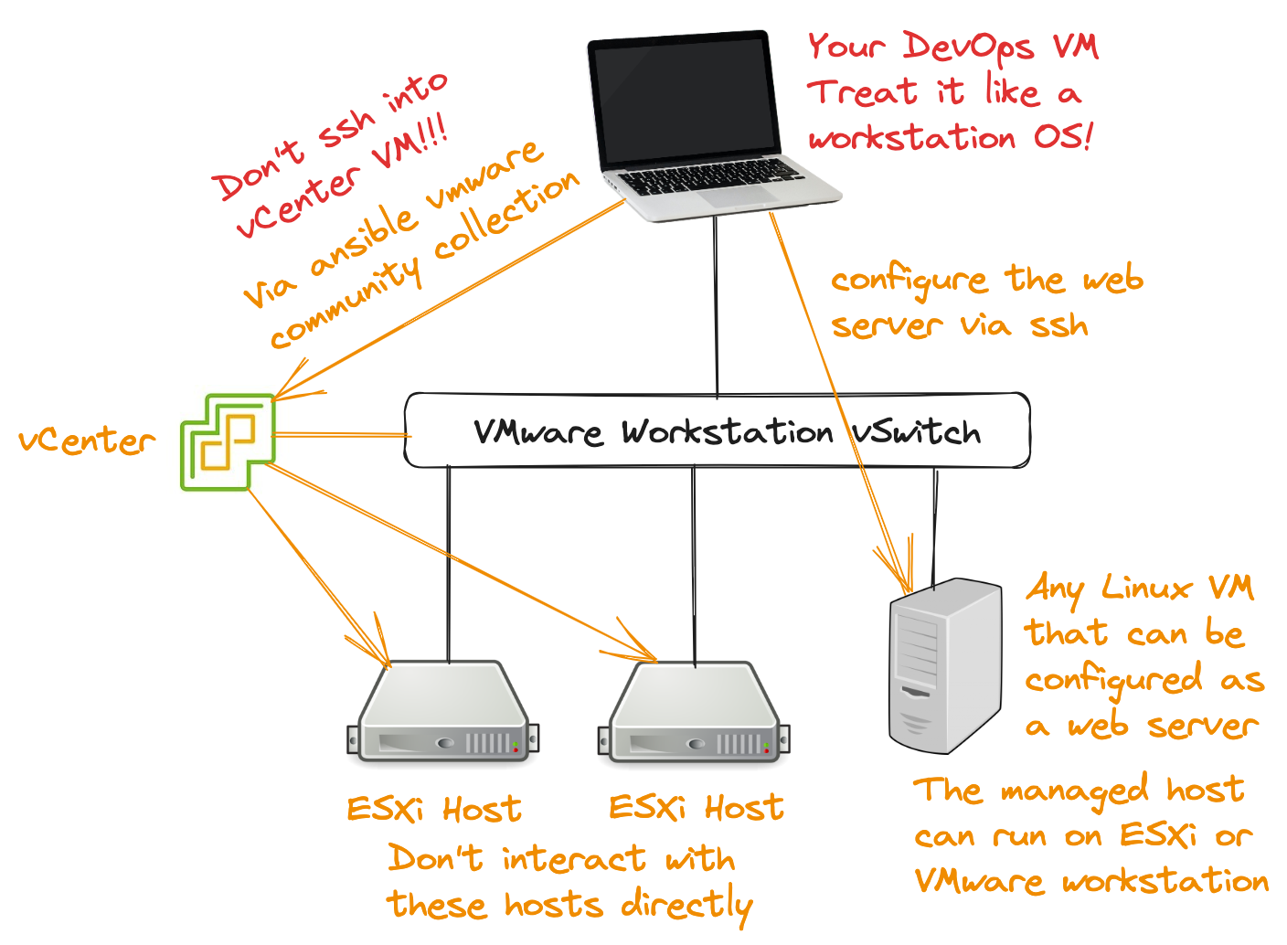

## Procedure

### Part A: Prepare the VMware vSphere Environment

Complete this part of the project individually, outside of class time.

1. Install two VMware ESXi hosts and install vCenter Server on one of the hosts.
2. Create an NFS server for shared storage that is accessible from both ESXi servers.

**Note:** Because vCenter Server’s Tiny Deployment requires 12 GB RAM, ensure that the target ESXi host has at least 13 GB RAM.

1. Create a datacenter in vSphere Client, and then add the two ESXi hosts to the datacenter.

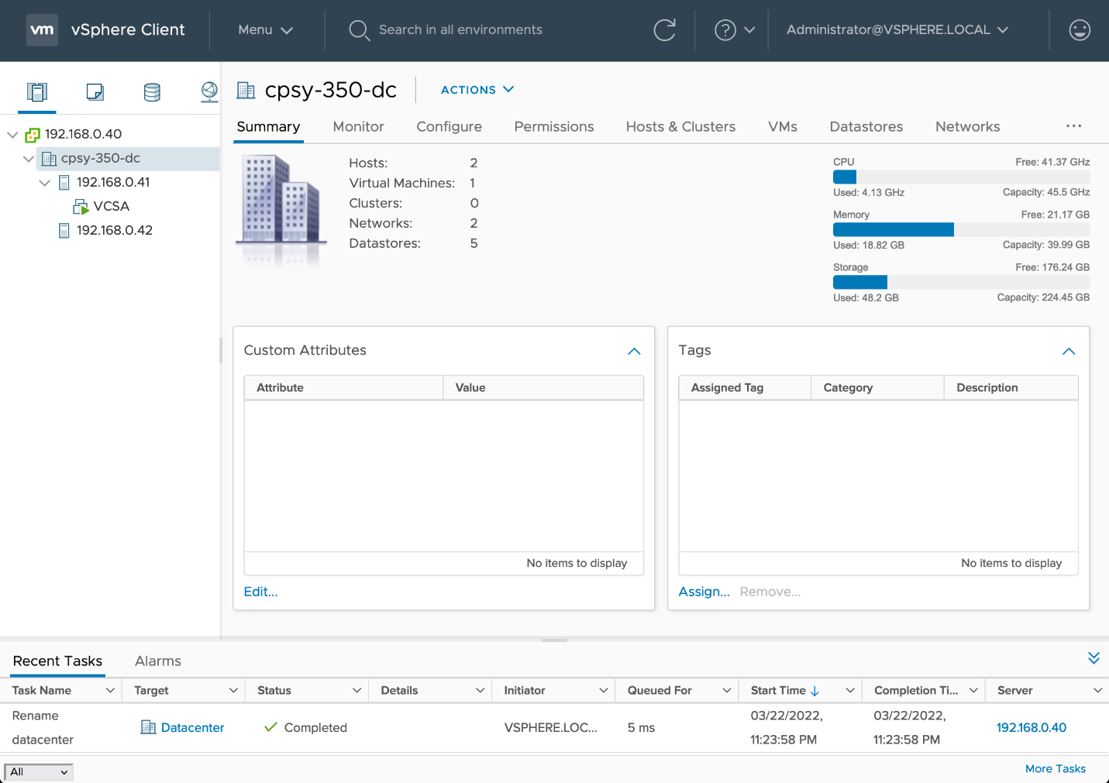

Figure 1: vCenter Server and Virtual Datacenter

Source: Broadcom, Inc., 2024. Reproduced and used in accordance with the fair dealing provisions in section 29 of the Canadian Copyright Act for the purposes of education, research or private study. Further distribution may infringe copyright.

1. Create an Alpine Linux virtual machine. Download the **VIRTUAL** x86_64 iso file at [downloads | Alpine Linux](https://www.alpinelinux.org/downloads/)

**Note:** Use the configuration shown in Figure 2 and deviate from it only as you deem necessary. Make sure the firmware type is **BIOS** (Figure 3).

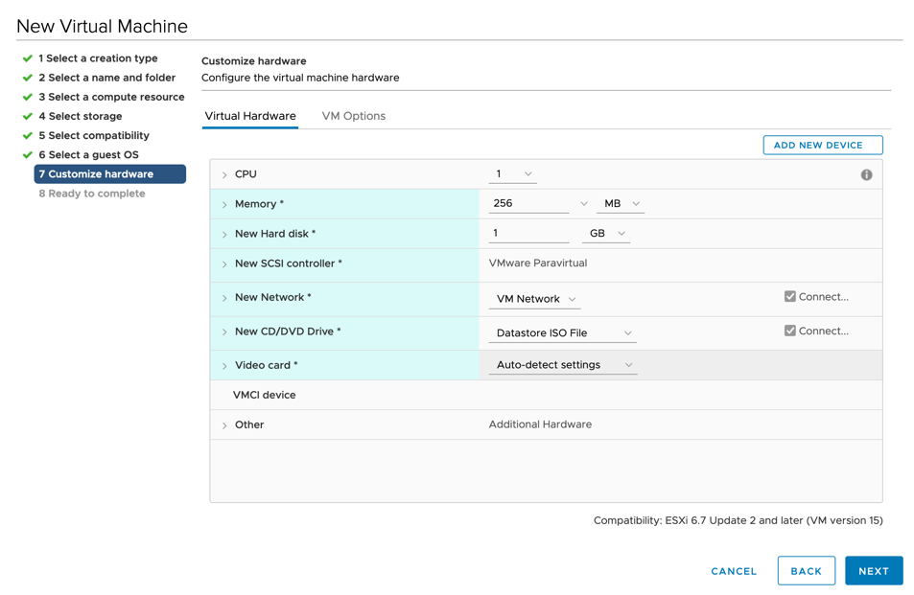

**Figure 2: Create a New Virtual Machine**

Source: Broadcom, Inc., 2024. Reproduced and used in accordance with the fair dealing provisions in section 29 of the Canadian Copyright Act for the purposes of education, research or private study. Further distribution may infringe copyright.

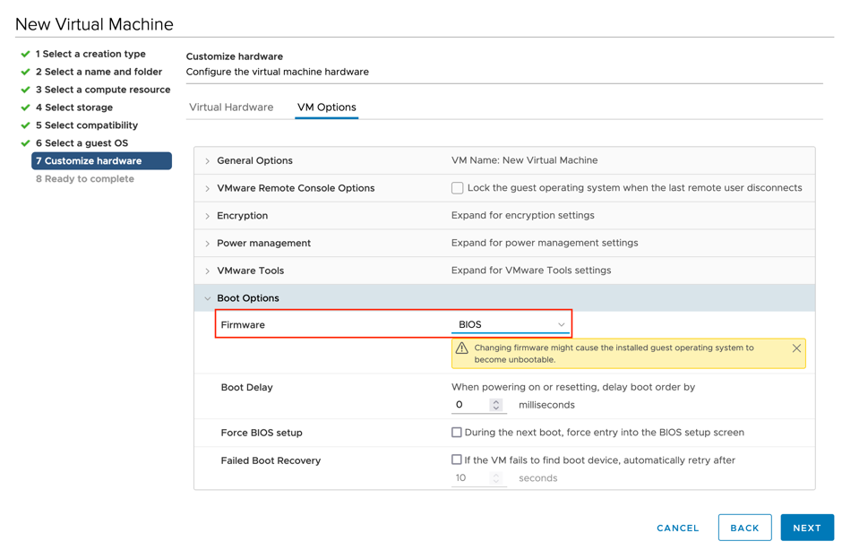

**Figure 3: Virtual Machine Firmware Type**

Source: Broadcom, Inc., 2024. Reproduced and used in accordance with the fair dealing provisions in section 29 of the Canadian Copyright Act for the purposes of education, research or private study. Further distribution may infringe copyright.

1. Perform a traditional hard-disk install of Alpine Linux. Read the Appendix for installation guide.
   1. Set a password for root user.
   2. Enable SSH root login on Alpine Linux.
   3. Use the command **apk add python3** to install python3 on the VM.

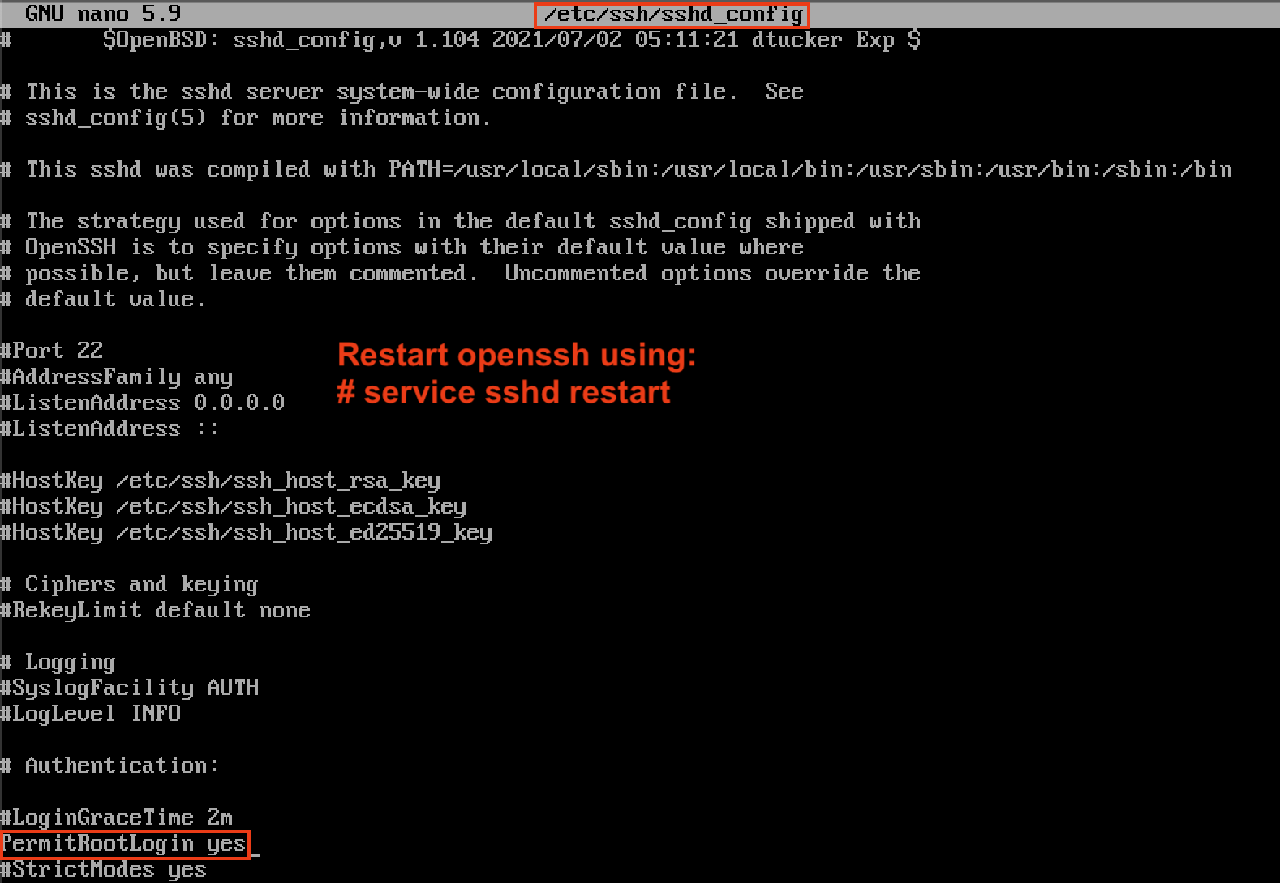

**Figure 4: Enable SSH Root Login**

© 2022, Southern Alberta Institute of Technology

1. Convert the Alpine Linux VM to a template.

**Note:** Templates are primary copies of virtual machines that let you create ready-for-use virtual machines (Broadcom, Inc., 2024).

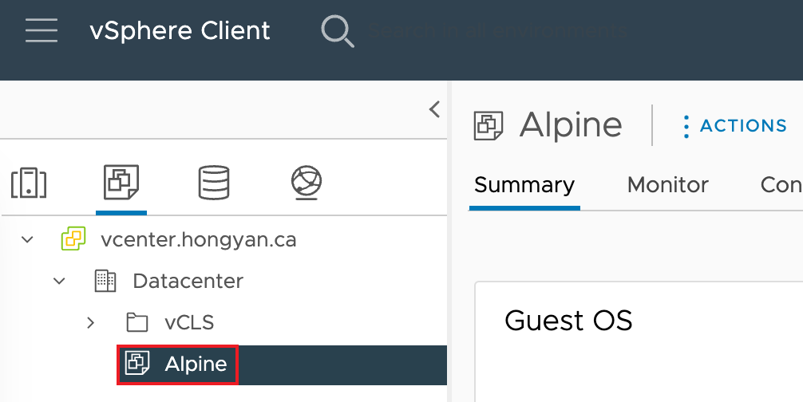

**Figure 5: Virtual Machine Template**

Source: Broadcom, Inc., 2024. Reproduced and used in accordance with the fair dealing provisions in section 29 of the Canadian Copyright Act for the purposes of education, research or private study. Further distribution may infringe copyright.

### Part B: Install Ansible on a Linux Virtual Machine

1. Follow the instructions on [Installing Ansible](https://docs.ansible.com/ansible/latest/installation_guide/intro_installation.html#installing-and-upgrading-ansible-with-pip) (<https://docs.ansible.com/ansible/latest/installation_guide/intro_installation.html#installing-and-upgrading-ansible-with-pip>) to install the latest version of Ansible on your control node.

**Notes:**

* The machine that runs Ansible is your control node.
* You can use any Linux distribution or macOS machine with Python 3.8 or newer installed. The control node OS used in screenshot figures is RHEL 9.3
* Although Ansible can manage Windows Servers, Microsoft Windows is not supported for the control node.

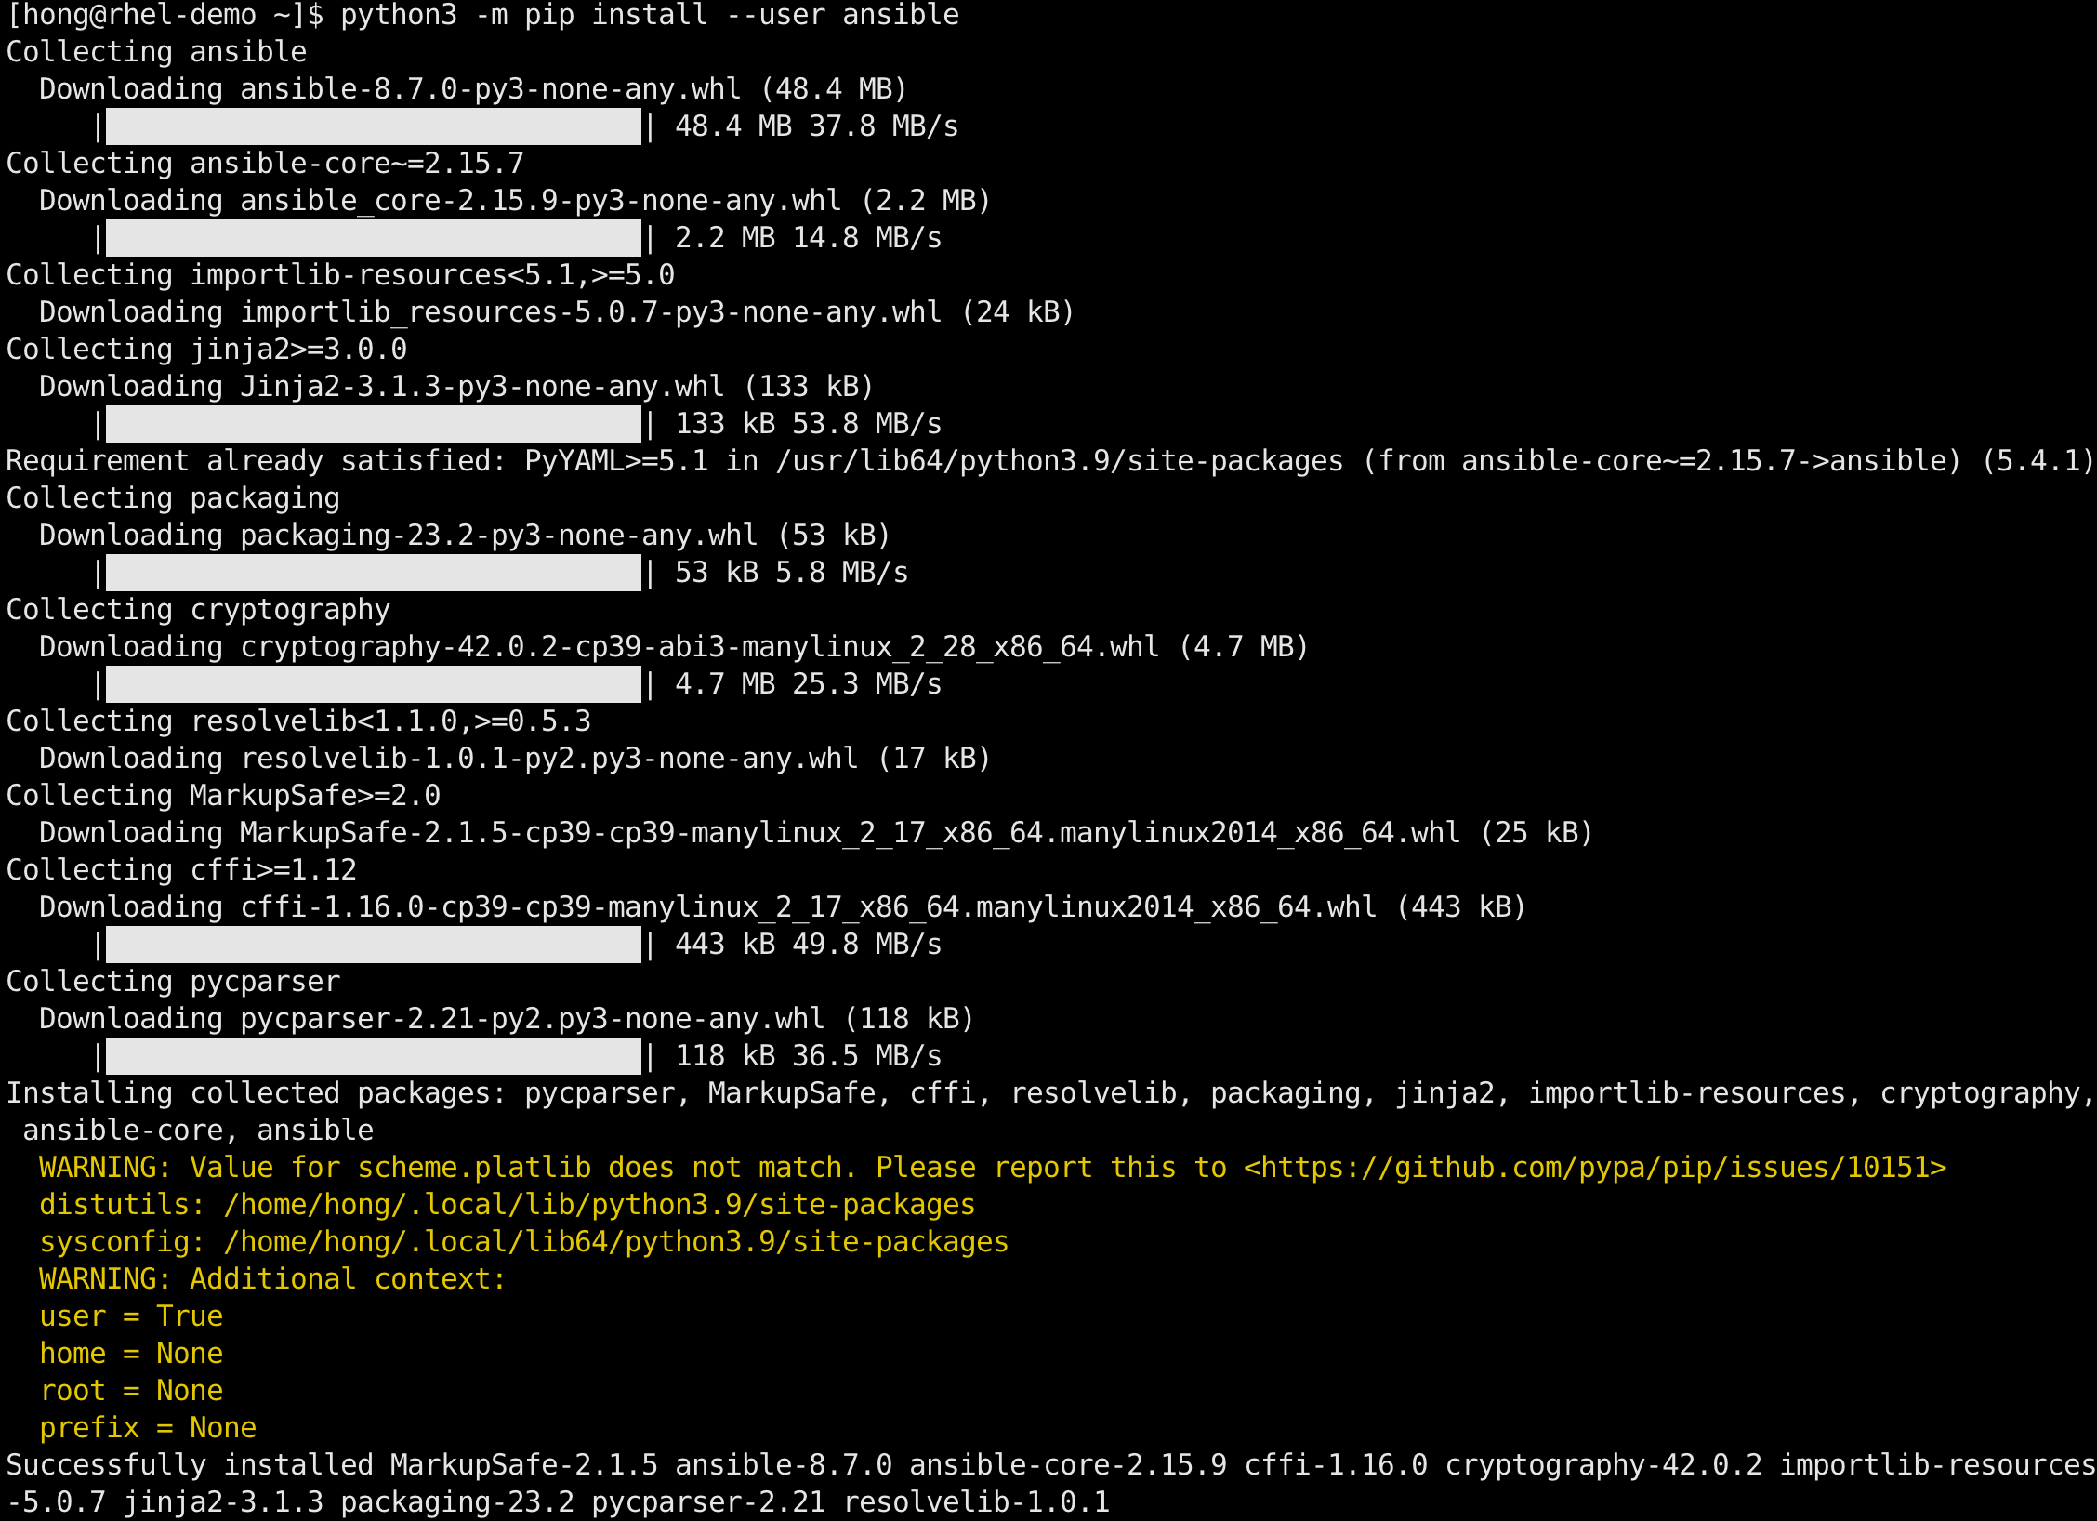

**Figure 6: Install Ansible**

Source: Red Hat, Inc., 2024. Reproduced and used in accordance with the fair dealing provisions in section 29 of the Canadian Copyright Act for the purposes of education, research or private study. Further distribution may infringe copyright.

1. You need community.vmware collection to manage VMware vSphere. Collections are a distribution format for Ansible content that can include playbooks, roles, modules and plugins. Follow the instructions on [Ansible Collection for VMWare](https://github.com/ansible-collections/community.vmware) (<https://github.com/ansible-collections/community.vmware>) to install community.vmware. Use `**--force**` argument.

**Note:** If the first installation attempt fails, try again.

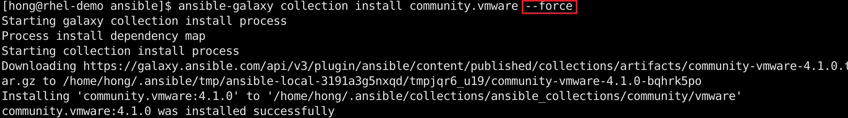

**Figure 7: Install the community.vmware Collection**

© 2024, Southern Alberta Institute of Technology

1. Because installing this collection doesn’t install any third-party Python libraries or SDKs, follow the instructions on the [Installing Required Libraries and SDK](https://github.com/ansible-collections/community.vmware?tab=readme-ov-file#installing-required-libraries-and-sdk) (<https://github.com/ansible-collections/community.vmware?tab=readme-ov-file#installing-required-libraries-and-sdk>) to install the required Python libraries.

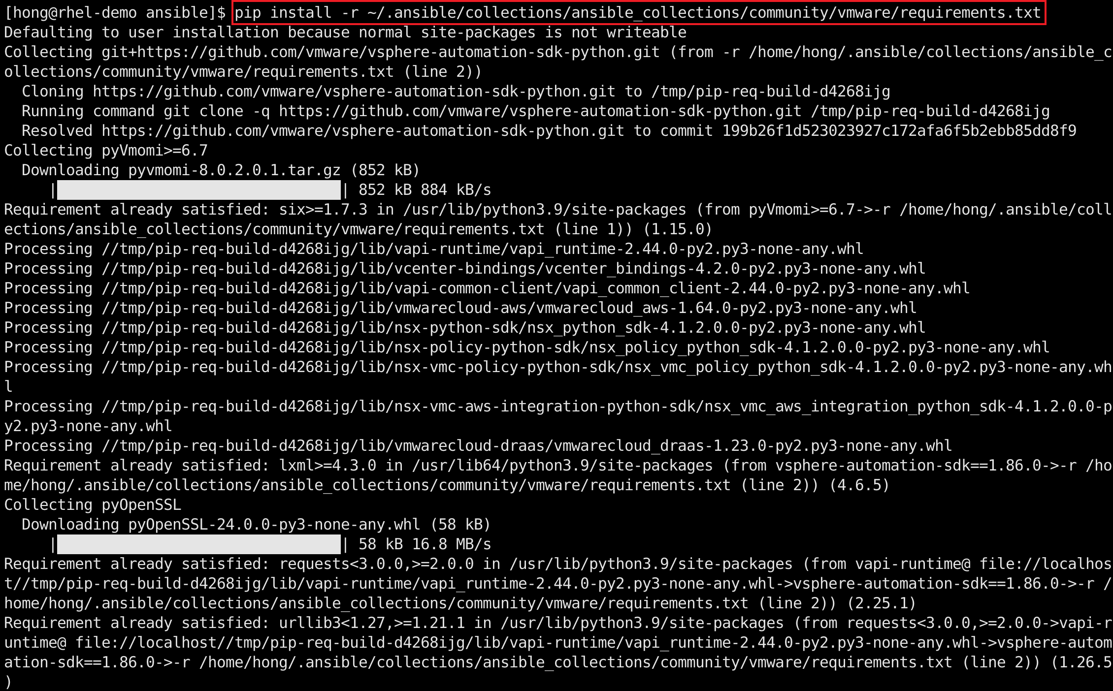

**Figure 8: Install Required Python Libraries for the community.vmware Collection**

© 2024, Southern Alberta Institute of Technology

### Part C: Gather Information About VMware ESXi Hosts

1. Use the module [community.vmware.vmware_host_facts](https://docs.ansible.com/ansible/latest/collections/community/vmware/vmware_host_facts_module.html#community-vmware-vmware-host-facts-module-gathers-facts-about-remote-esxi-hostsystem) (<https://docs.ansible.com/ansible/latest/collections/community/vmware/vmware_host_facts_module.html#ansible-collections-community-vmware-vmware-host-facts-module>) to gather facts about the ESXi host system from the vCenter Server, including its memory, datastore, network and system.

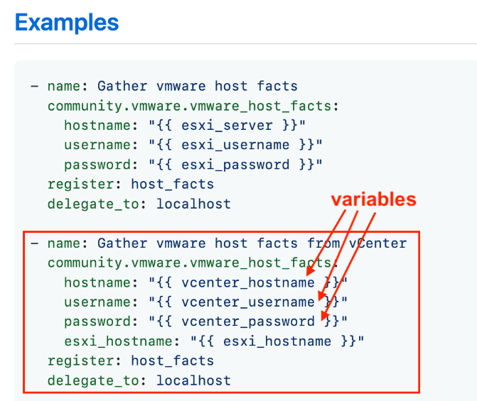

**Figure 9: Examples of Gathering VMware Host Facts**

Source: VMware Working Group, 2024. Reproduced and used in accordance with the fair dealing provisions in section 29 of the Canadian Copyright Act for the purposes of education, research or private study. Further distribution may infringe copyright.

The example code snippet shown in Figure 9 uses variables but does not have the code that includes variables defined in external files. When you define variables in reusable variable files, the sensitive variables are separated from playbooks. This separation enables you to store your playbooks in a source control software, and even share the playbooks, without the risk of exposing passwords or other sensitive and personal data (Ansible, 2024).

1. Create two variable definition files in a subfolder called **vars**.
2. Replace the vCenter login credentials, vCenter IP address and ESXi host IP addresses with the actual values of your environment.

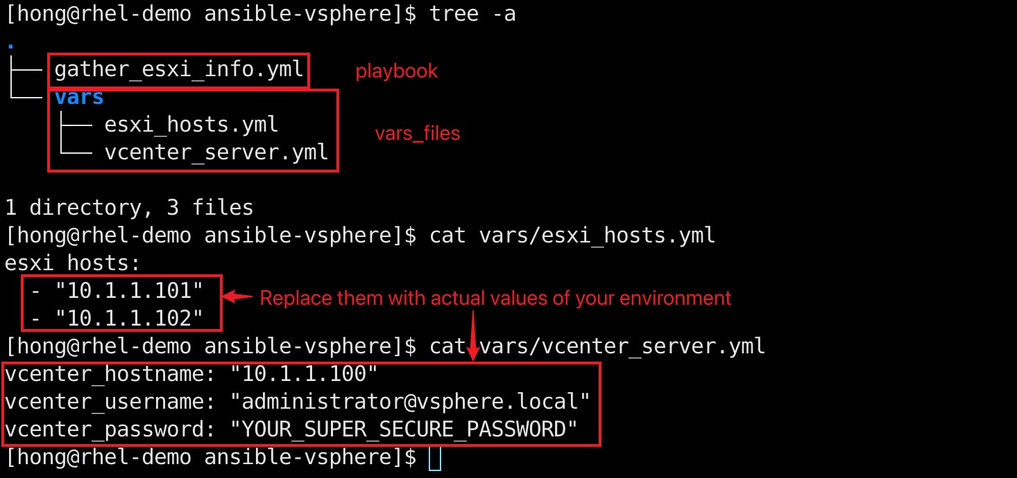

**Figure 10: Separate Sensitive Variables from Playbooks**

© 2024, Southern Alberta Institute of Technology  
  
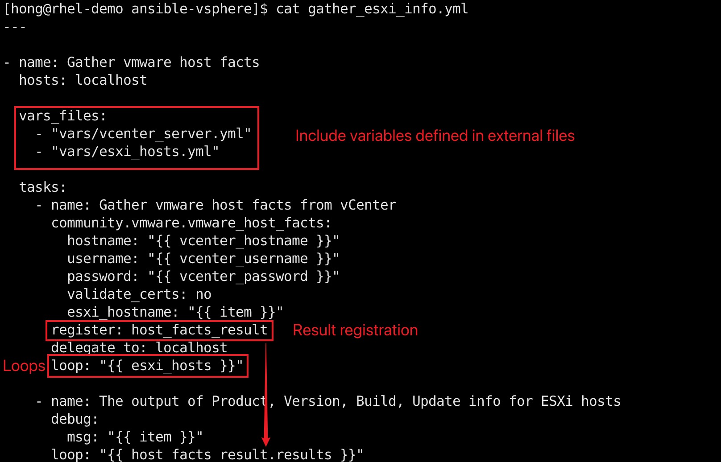

**Figure 11: Ansible Playbook that Gathers ESXi Host Information**

© 2024, Southern Alberta Institute of Technology

1. Create a playbook file called **gather_esxi_info.yml**.

The **vars_files** section includes external variable files. Ansible loops can execute a task multiple times. In the demo code, **esxi_hostname: "{{ item }}"** iterates over the list of ESXi hosts defined in **loop: "{{ esxi_hosts }}"** and gathers information for each host. The **register: host_facts_result** creates a new variable from the return values of the **vmware_host_facts** task. The **debug** task displays the collected results.

1. Run **ansible-playbook gather_esxi_info.yml** to gather VMware ESXi host facts.

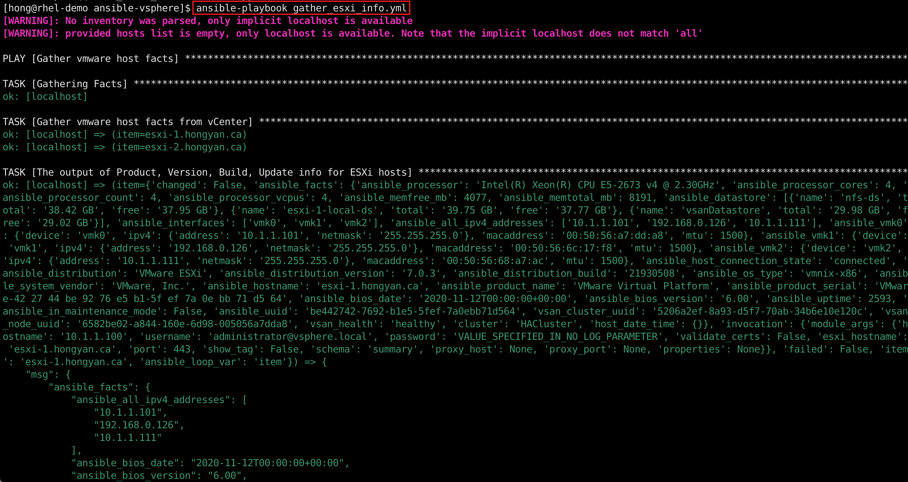

**Figure 12: Run an Ansible Playbook**

© 2024, Southern Alberta Institute of Technology

* For more information about variables, see [Using variables](https://docs.ansible.com/ansible/latest/user_guide/playbooks_variables.html) (https://docs.ansible.com/ansible/latest/user_guide/playbooks_variables.html)
* For more information about loops, see [Loops](https://docs.ansible.com/ansible/latest/user_guide/playbooks_loops.html) (<https://docs.ansible.com/ansible/latest/user_guide/playbooks_loops.html>)
* If you encounter “[SSL: CERTIFICATE_VERIFY_FAILED] certificate verify failed: unable to get local issuer certificate” error, add “**validate_certs: no**” under password.  
  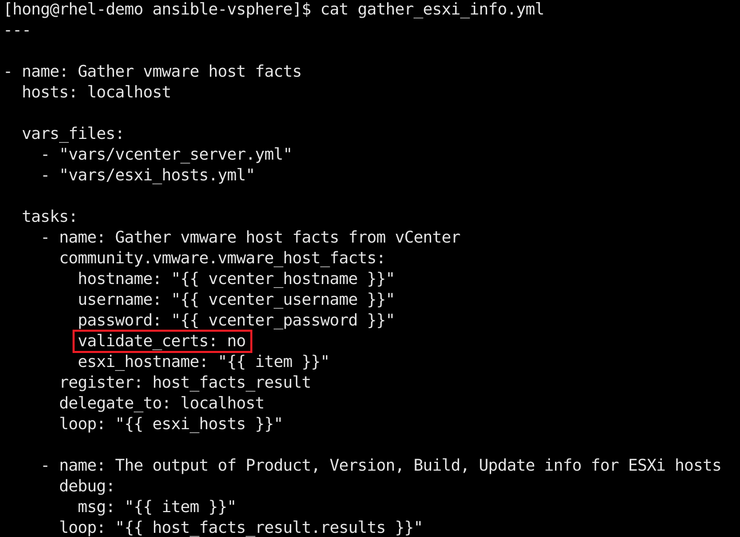

### Part C: Create a Virtual Machine from a Template

1. Create a **create_vm.yml** playbook.   
   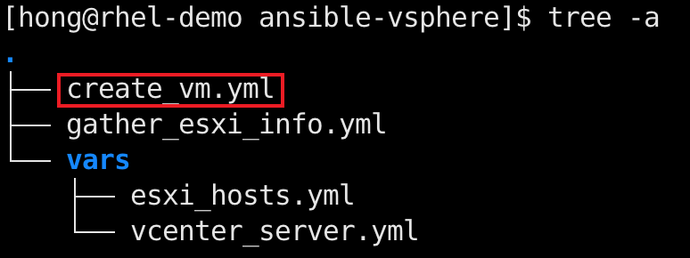
   1. Use the module [vmware_datacenter_info](https://docs.ansible.com/ansible/latest/collections/community/vmware/vmware_datacenter_info_module.html#ansible-collections-community-vmware-vmware-datacenter-info-module) (<https://docs.ansible.com/ansible/latest/collections/community/vmware/vmware_datacenter_info_module.html#ansible-collections-community-vmware-vmware-datacenter-info-module>) to create an Ansible playbook task that gathers VMware vSphere data center information from vCenter server.
   2. Register the results to a new variable **dc_info**.

**Note**: If you encounter “[SSL: CERTIFICATE_VERIFY_FAILED] certificate verify failed: unable to get local issuer certificate” error, add “**validate_certs: no**” under password.

1. In the same playbook, write another task that creates a virtual machine from the template you converted in Part A. (<https://docs.ansible.com/ansible/latest/collections/community/vmware/vmware_guest_module.html>)
   1. Use the registered variable **dc_info** to assign the data center for the VM.
   2. Name the VM **http_server**.

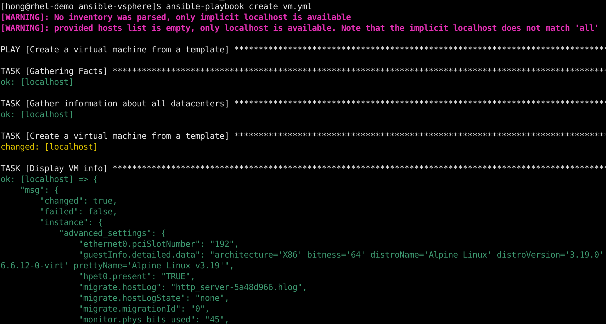

**Figure 12: Use Ansible to Create a VM from a Template**

© 2024, Southern Alberta Institute of Technology

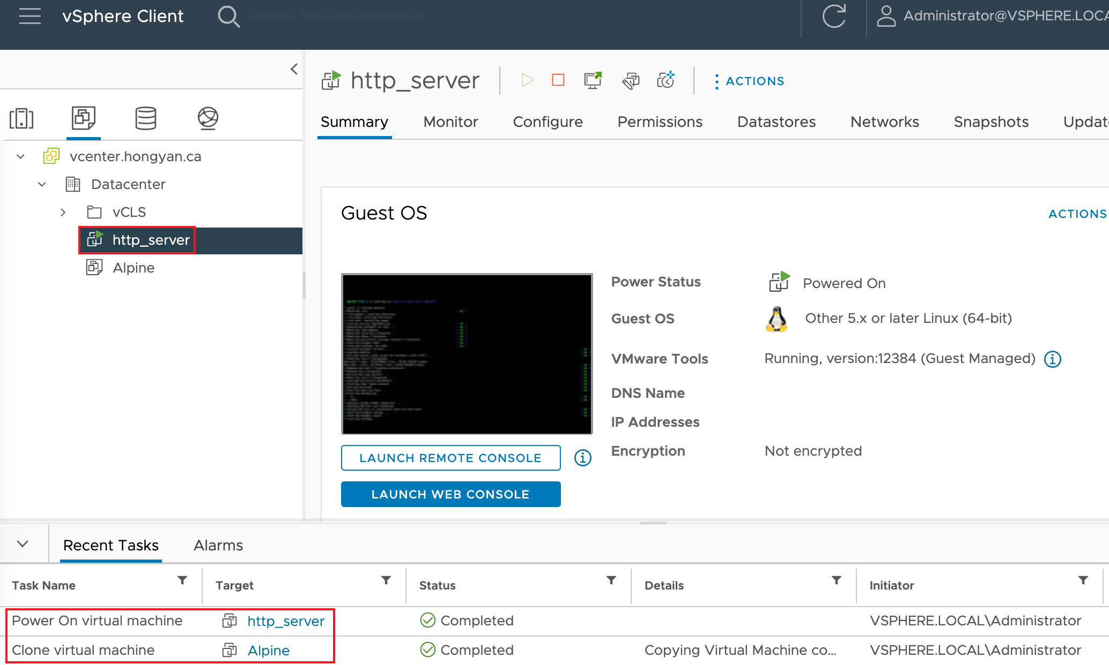

**Figure 13: VM Created by Ansible**

Source: Broadcom, Inc., 2024. Reproduced and used in accordance with the fair dealing provisions in section 29 of the Canadian Copyright Act for the purposes of education, research or private study. Further distribution may infringe copyright.

### Part D: Configure the VM as a Web Server

Ansible works against multiple managed nodes or “hosts” in your infrastructure at the same time, using a list or group of lists known as *inventory*. Once your inventory is defined, you can use patterns to select the hosts or groups you want Ansible to run against (Ansible, 2024).

1. Create an Ansible configuration file that specifies the inventory.  
   **Note**: If you receive **`[WARNING]: Platform linux on host xxx is using the discovered Python interpreter at /usr/bin/python3.xx, but future installation of another Python interpreter could change the meaning of that path...**`, read <https://docs.ansible.com/ansible-core/2.17/reference_appendices/interpreter_discovery.html> for required change to **ansible.cfg** file.
2. Create a inventories subfolder with required inventory files.

* For more information about inventory, see [How to build your inventory](https://docs.ansible.com/ansible/latest/user_guide/intro_inventory.html) (https://docs.ansible.com/ansible/latest/user_guide/intro_inventory.html)
* For more information about configuration file see [Configuring Ansible](https://docs.ansible.com/ansible/latest/installation_guide/intro_configuration.html) (https://docs.ansible.com/ansible/latest/installation_guide/intro_configuration.html)

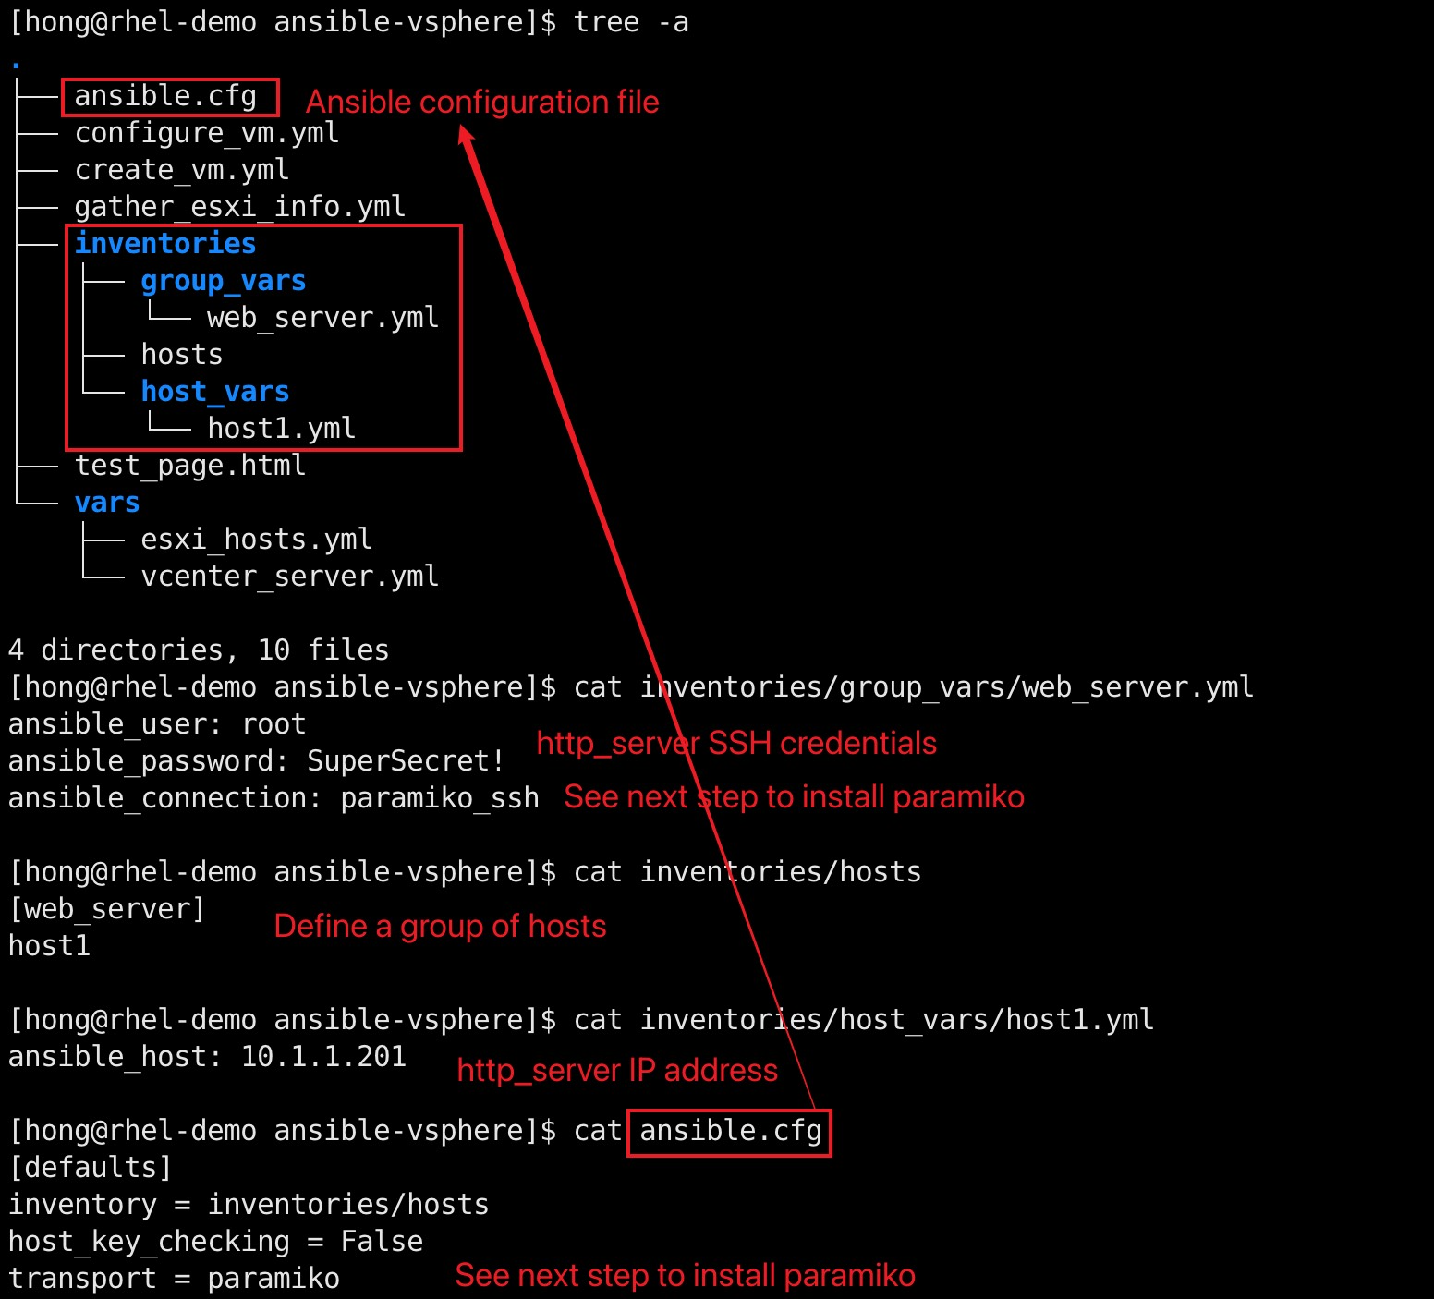

**Figure 14: Ansible Configuration File and Inventory**

© 2024, Southern Alberta Institute of Technology

1. On the control node, install [Paramiko](https://www.paramiko.org/installing.html), a Python implementation of SSHv2  
   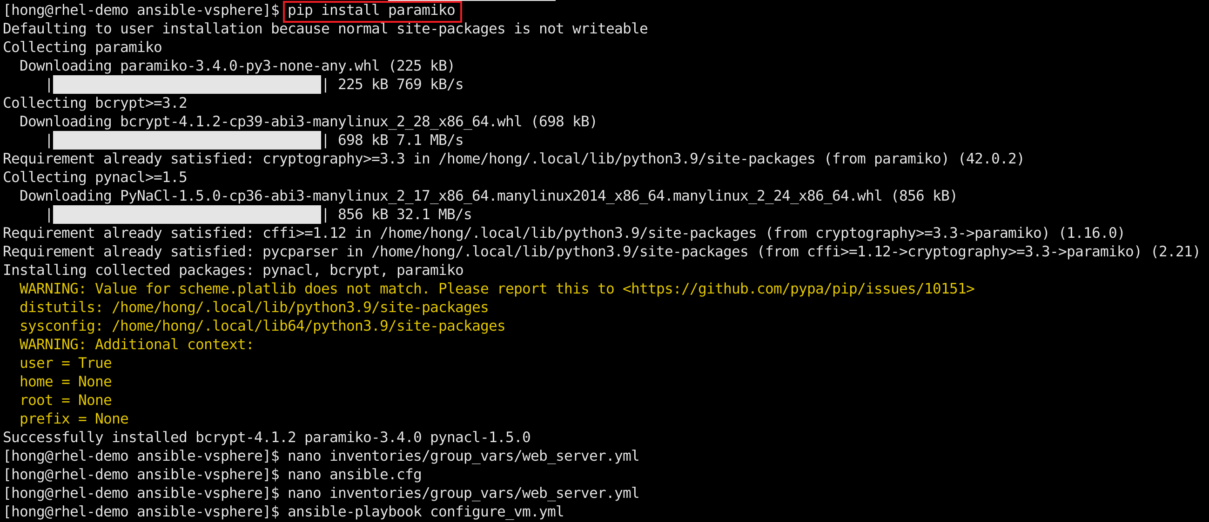
2. Create a **configure_vm.yml** playbook.
3. Create a task that installs **lighttpd** package using the examples from <https://docs.ansible.com/ansible/latest/collections/community/general/apk_module.html>.

**Note:** Alpine Linux uses apk as its package management tool to install, upgrade or delete software. Ansible uses the community.general.apk module to manage apk packages.

1. The **command** module can be used to execute commands on managed targets. Create a task that uses command module to execute "**rc-update add lighttpd default**" to add the lighttpd as a service.

See examples of the command module at <https://docs.ansible.com/ansible/latest/collections/ansible/builtin/command_module.html>

1. Create a task that uses the **command** module to execute "**rc-service lighttpd restart**" to restart the lighttpd service.
2. The **ansible.builtin.copy** module copies a file from the local machine to a location on the managed remote machine. See examples of the ansible.builtin.copy module at <https://docs.ansible.com/ansible/latest/collections/ansible/builtin/copy_module.html>
   1. Create a **test_page.html** file that contains a single line of web server response with your SAIT ID.

**Note:** By default, lighttpd serves static contents from **/var/www/localhost/htdocs/index.html** folder.

* 1. Create a task that uses **copy** module to copy the **test_page.html** file to **/var/www/localhost/htdocs/index.html** on the http_server VM.

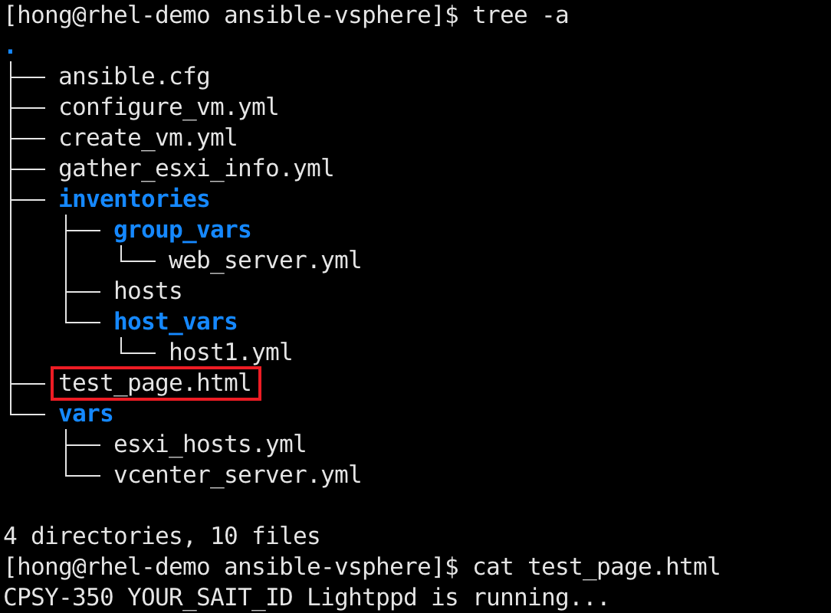

**Figure 15: test_page.html File**

© 2024, Southern Alberta Institute of Technology

1. Run the playbook to configure the VM as a web server.

**Note:** If you encounter a “Failed to authenticate” error, make sure you have enabled ssh root login, as shown in Part A. If you see a “No python interpreters found” error, make sure you have installed python3, as shown in Part A. **SSH into the http_server from the control node to verify the SSH configure**.

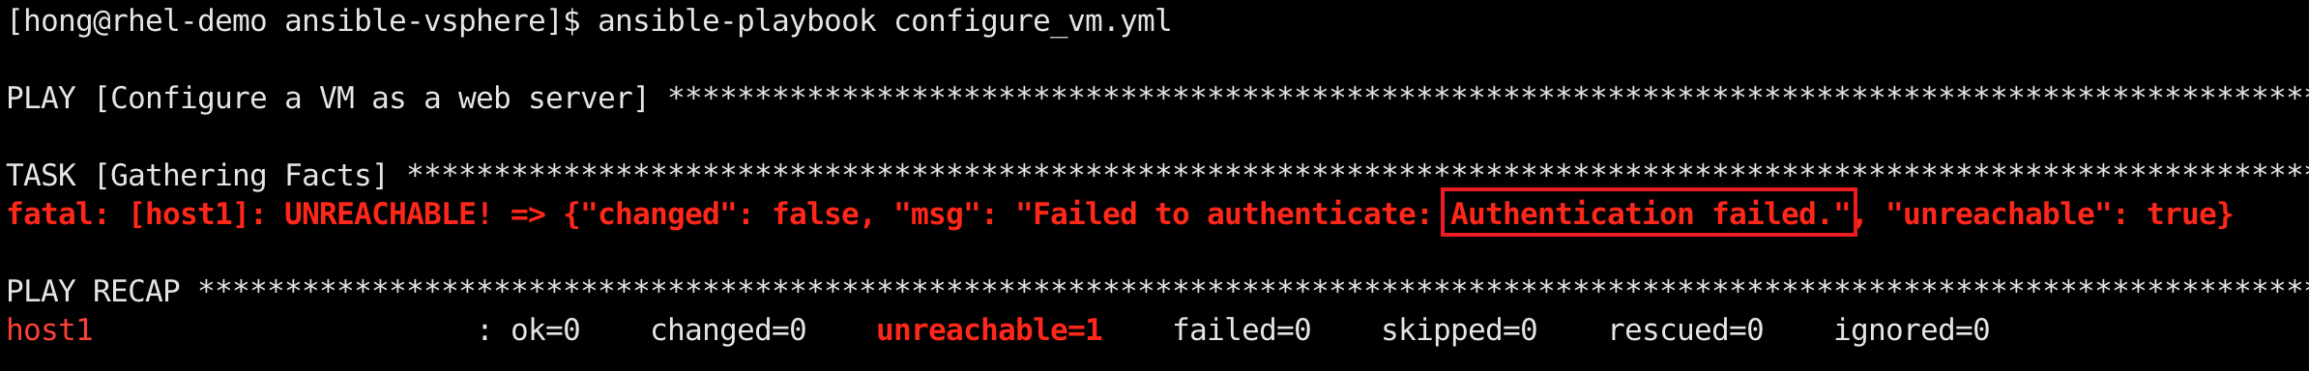

**Figure 16: Authentication Error**

© 2024, Southern Alberta Institute of Technology

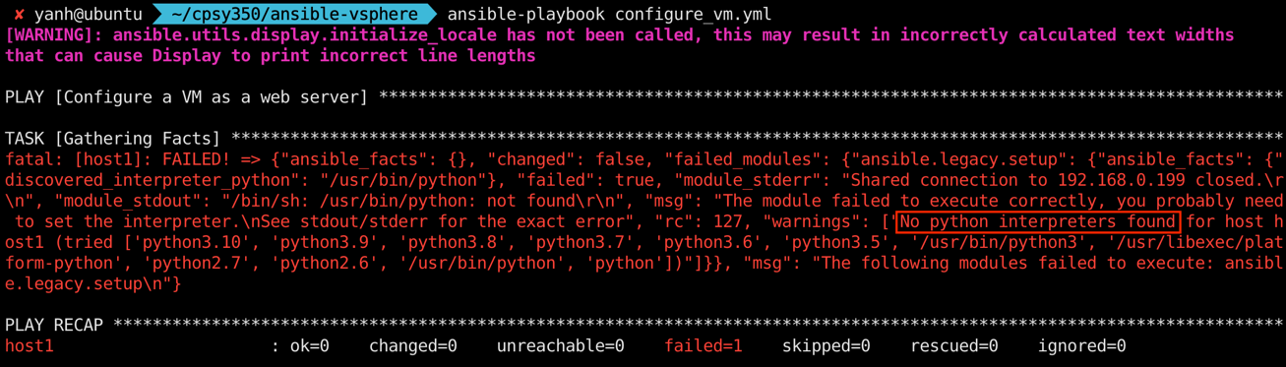

**Figure 17: No Python Interpreters Found Error**

© 2022, Southern Alberta Institute of Technology

The successful execution of configure_vm.yml installs a lighttpd package as a service and act as a web server. Type <http://YOUR_HTTP_SERVER_IP> in a browser to verify that lighttpd service is running and serving the webpage defined in test_page.html

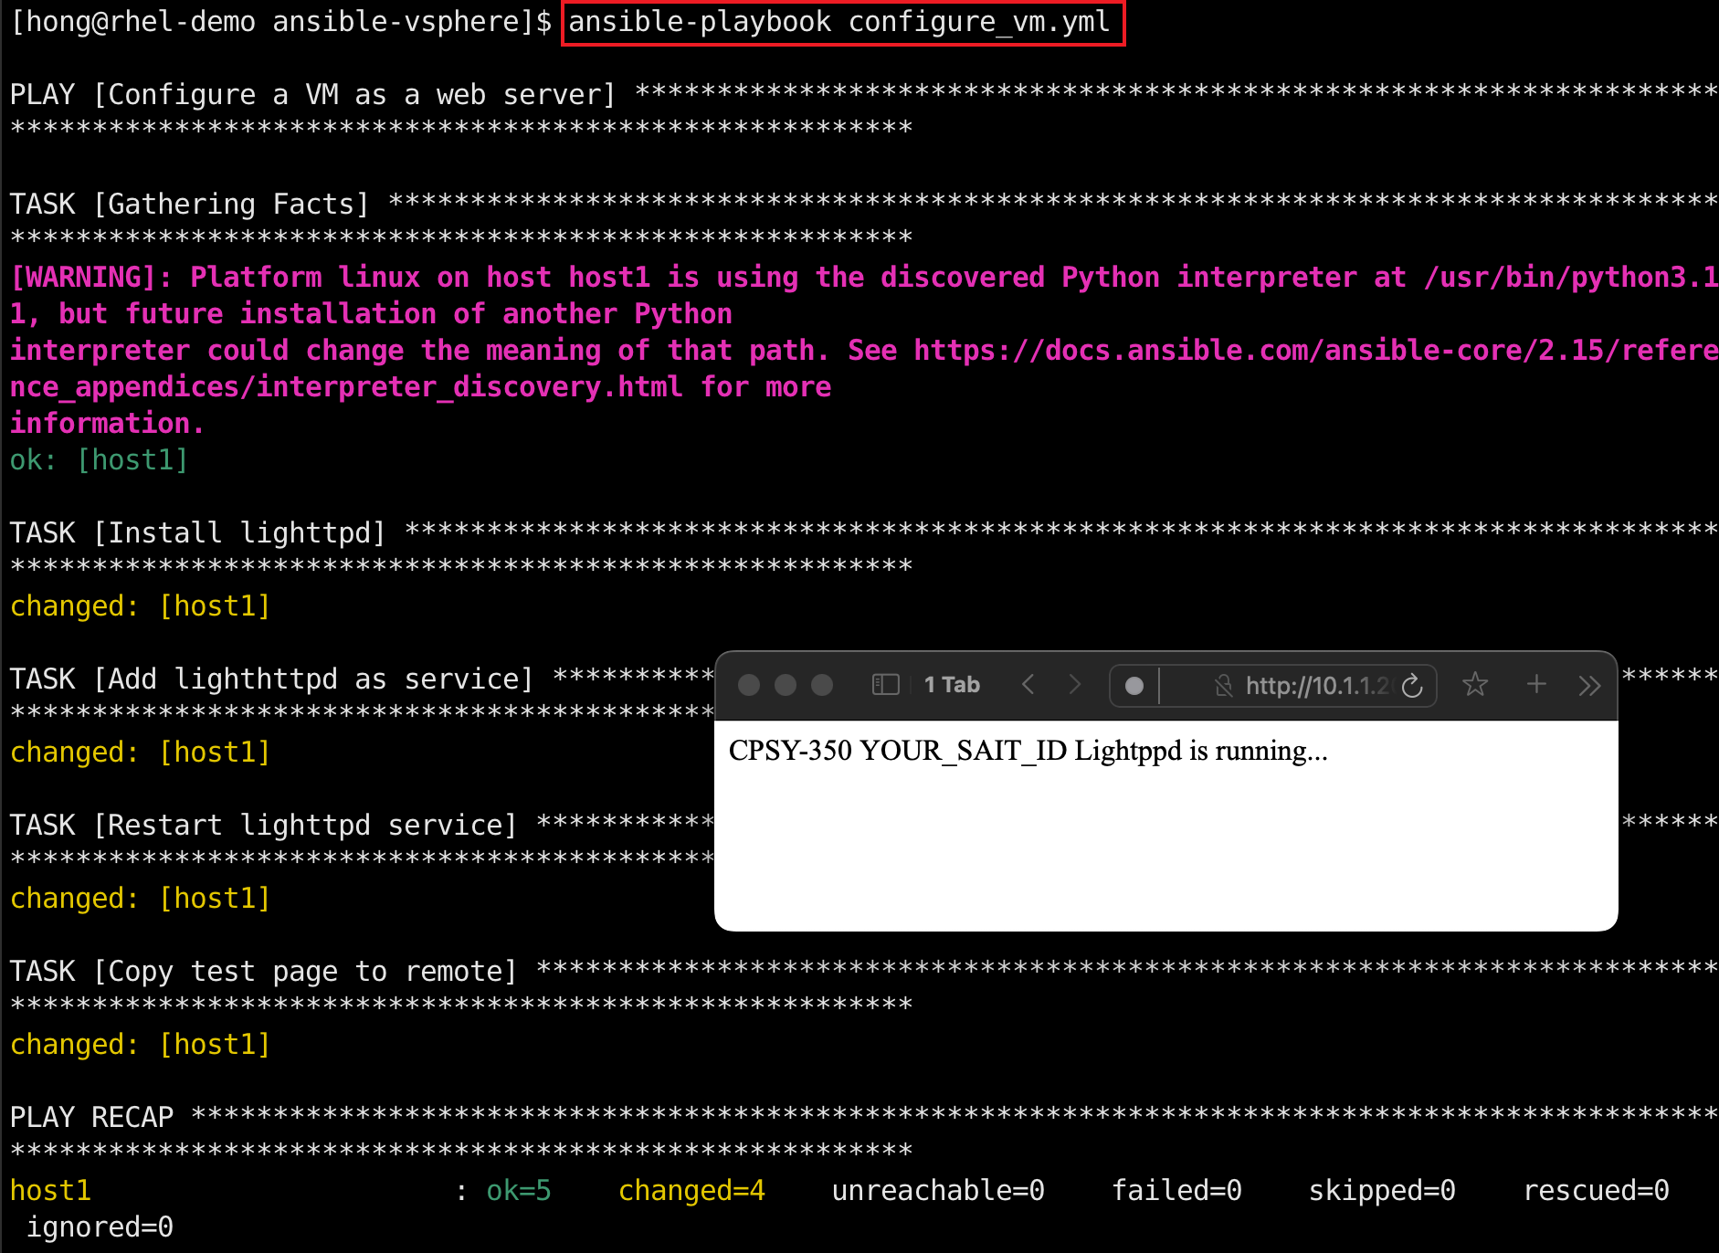

**Figure 18: Successful Execution of configure_vm.yml Playbook**

© 2024, Southern Alberta Institute of Technology

### Part E: Demonstrations

In this section, you will conduct a live demonstration of what you’ve learned for your instructor. Your instructor will indicate whether this portion of the project will occur face to face or online. See the marking criteria at the end of this document for details of how you will be assessed.

#### Lab Demonstrations

* **Demo 1:** Install Ansible and the required collections and libraries on a control node (Figure 6, Figure 7 and Figure 8).
* **Demo 2:** Use Ansible to gather information about ESXi hosts from vCenter.
* **Demo 3:** Use Ansible to create a VM from a template.
* **Demo 4:** Use Ansible to configure the VM as a webserver.

### Part F: Submit Files

Submit your **create_vm.yml** and **configure_vm.yml** files to Brightspace.

## Marking Criteria

|  |  |  |  |  |  |
| --- | --- | --- | --- | --- | --- |
| **Criteria** | **Poor** | **Satisfactory** | **Good** | **Excellent** | **Marks** |
| **Demo 1: Install Ansible** | Fails to install Ansible | Installs Ansible but fails to install collections or libraries  2/10 | N/A | Installs Ansible and required collections and libraries successfully  10/10 | /10 |
| **Demo 2: Gather ESXi Host Information** | Fails to gather ESXi information | N/A | N/A | Gathers ESXi information successfully  10/10 | /10 |
| **Demo 3: Create VM from a Template** | Fails to create VM | Creates a VM but fails to create it from template  5/30 | Creates a VM from template but dc_info is hard coded  10/30 | Creates a VM from template using registered dc_info successfully  30/30 | /30 |
| **Demo 4: Configure VM as a Web Server** | Fails to manage the VM | Installs lighttpd but fails to make is as a service  5/10 | Installs lighttpd and make it as a service but fails to copy the web page file  10/50 | Configure the VM as a web server and serves web page successfully  50/50 | /50 |
| **Total** | | | | | **/100** |

# Resources

* [YAML Syntax](https://docs.ansible.com/ansible/latest/reference_appendices/YAMLSyntax.html) (<https://docs.ansible.com/ansible/latest/reference_appendices/YAMLSyntax.html>)
* [Installing Ansible](https://docs.ansible.com/ansible/latest/installation_guide/intro_installation.html) (<https://docs.ansible.com/ansible/latest/installation_guide/intro_installation.html>)
* [Ansible Collection for VMware](https://github.com/ansible-collections/community.vmware) (<https://github.com/ansible-collections/community.vmware>)
* [Community.Vmware](https://docs.ansible.com/ansible/latest/collections/community/vmware/index.html) (<https://docs.ansible.com/ansible/latest/collections/community/vmware/index.html>)
* [Ansible VMware Guide](https://docs.ansible.com/ansible/latest/collections/community/vmware/docsite/scenario_guide.html) (<https://docs.ansible.com/ansible/latest/collections/community/vmware/docsite/scenario_guide.html>)
* [Lighttpd](https://wiki.alpinelinux.org/wiki/Lighttpd) (<https://wiki.alpinelinux.org/wiki/Lighttpd>)
* [Community.general.apk – Manages apk packages](https://docs.ansible.com/ansible/latest/collections/community/general/apk_module.html) (<https://docs.ansible.com/ansible/latest/collections/community/general/apk_module.html>)
* [ansible.builtin.command – Execute commands on targets](https://docs.ansible.com/ansible/latest/collections/ansible/builtin/command_module.html) (<https://docs.ansible.com/ansible/latest/collections/ansible/builtin/command_module.html>)
* [ansible.builtin.file – Manage files and file properties](https://docs.ansible.com/ansible/latest/collections/ansible/builtin/file_module.html) (<https://docs.ansible.com/ansible/latest/collections/ansible/builtin/file_module.html>)
* [ansible.builtin.copy module](https://docs.ansible.com/ansible/latest/collections/ansible/builtin/copy_module.html) (<https://docs.ansible.com/ansible/latest/collections/ansible/builtin/copy_module.html>)

# References

Broadcom, Inc. (2024). VMware vSphere Documentation. Retrieved from https://docs.vmware.com/en/VMware-vSphere/index.html

Red Hat, Inc. (2024). Red Hat Ansible Automation Platform [computer software]. Retrieved from https://www.ansible.com/

Red Hat, Inc. (2024). Ansible Documentation. Retrieved from https://docs.ansible.com/

# Appendix

## Install Alpine Linux in ESXi

1. Upload an ISO file containing Alpine Linux installation media (<https://dl-cdn.alpinelinux.org/alpine/v3.19/releases/x86_64/alpine-virt-3.19.1-x86_64.iso>) to datastore. Navigate to the local datastore, click on “Datastore browser”, create an “iso” directory.  
   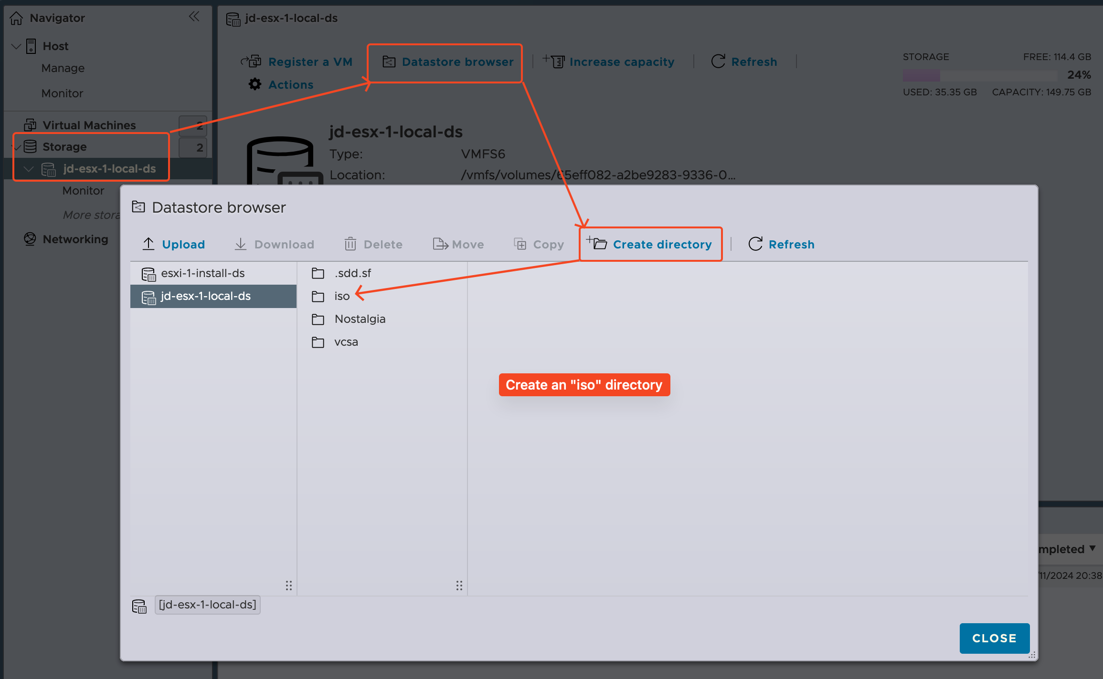
2. Click on the “iso” directory, then click on “Upload” to upload an ISO file containing an OS installation media. The following screenshot shows “alpine-virt-3.19.1-x86_64.iso” file been uploaded to “iso” directory.  
   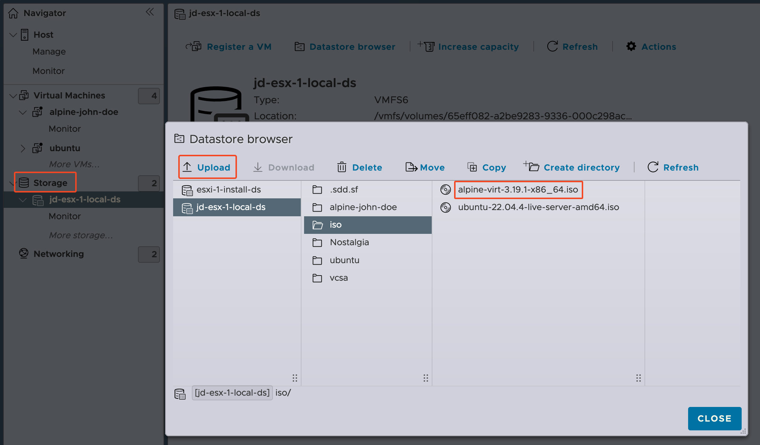
3. To create a VM in ESXi host, click “Virtual Machines” in the left pane. Click the “Create / Register VM” button, and you will see following pop-up dialog.  
   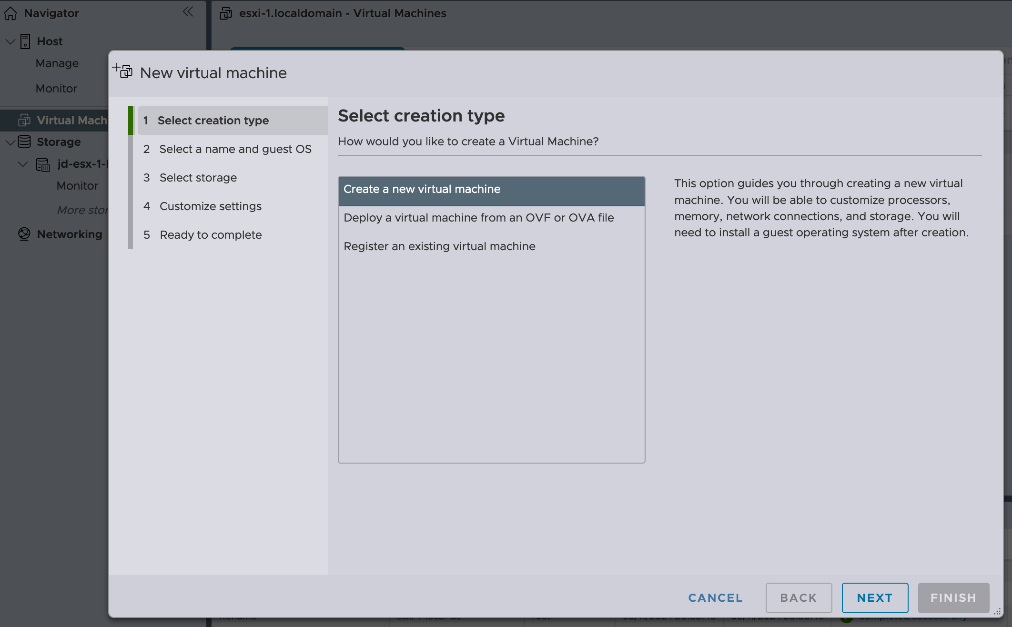
4. Select the “Create a new virtual machine” option from the pop-up dialog. Then, click Next. On the "Select a name and guest OS" screen, enter the relevant information to the OS you would like to install and choose a meaningful name for your VM, and select the Guest OS family and version based on the VM you are installing. Then, click Next.  
   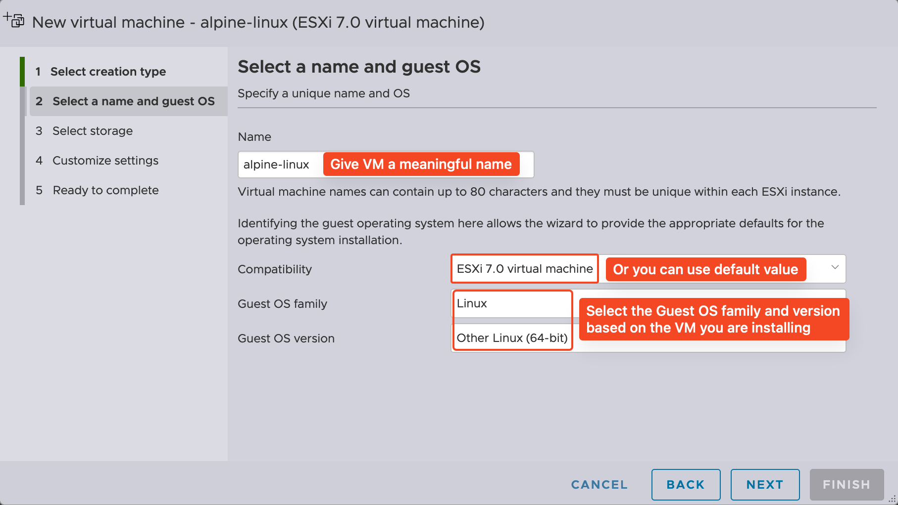
5. On the following screen, you can select the datastore on which you wish to store your VM and then click Next.  
   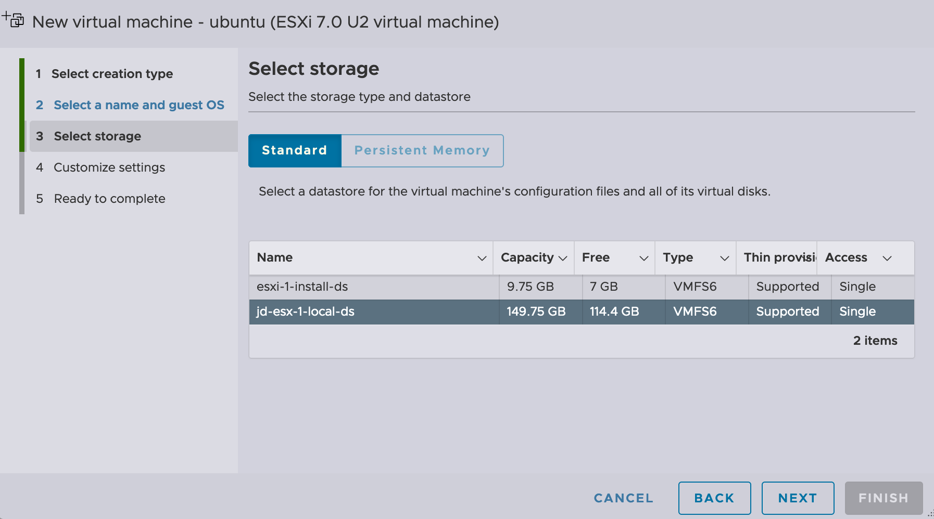
6. This brings us to our virtual hardware settings. During the customization of virtual hardware, it is important to verify the hardware specifications required by the operating system you are installing and configure the values accordingly. Make sure all the are sufficient for the operating system you are using as well as the programs the VM will be running. 1 CPU core, 1 GB RAM and 1 GB Hard Disk are sufficient for Alpine Linux.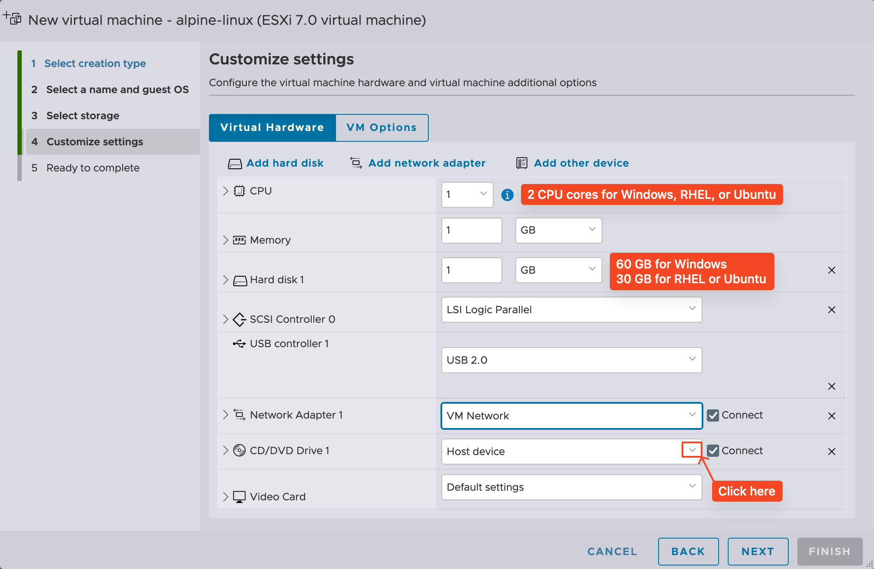
7. Click on the drop down menu to the right of “CD/DVD Drive 1”, select “Datastore ISO file” instead of “Host Device”. Select the iso file uploaded in step 2.  
   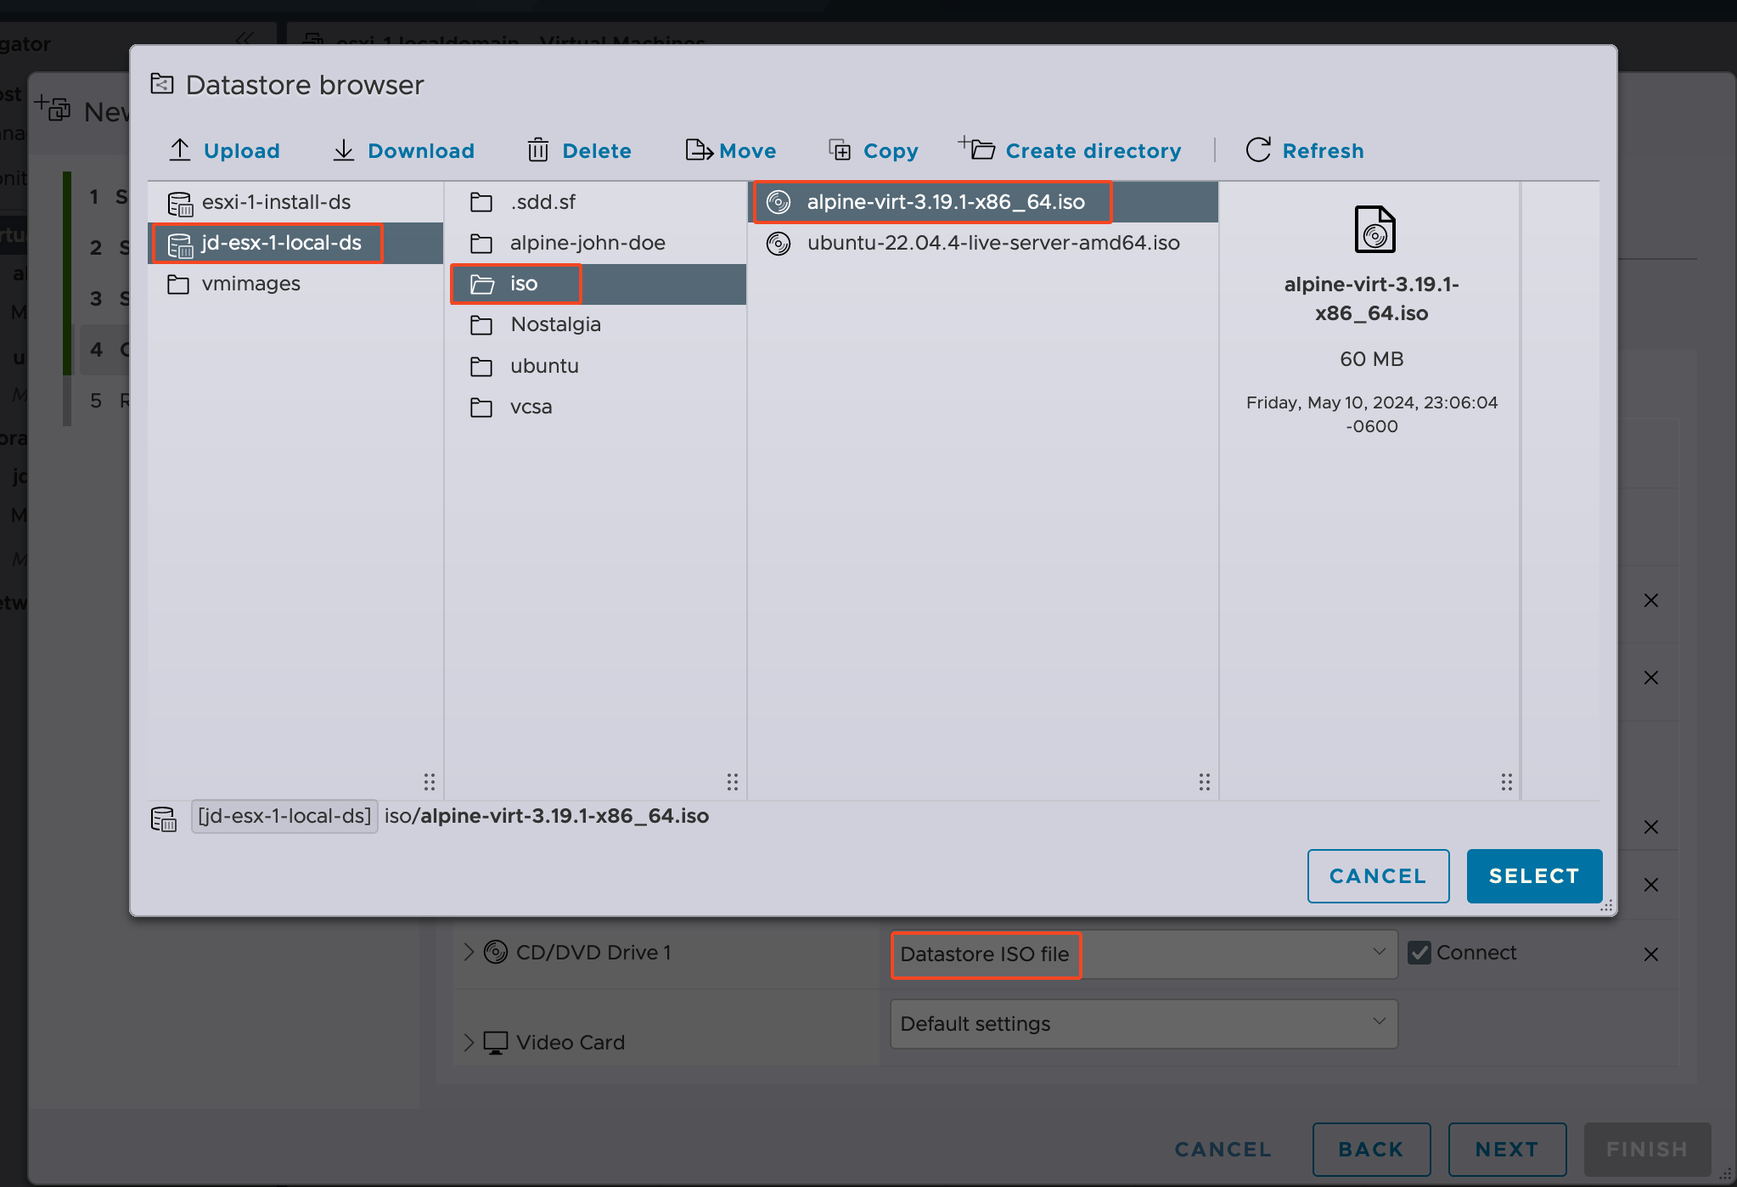
8. After you click the “SELECT” button, click “VM Options” next to “Virtual Hardware”. Ensure that Boot Options -> Firmware is set to BIOS.  
   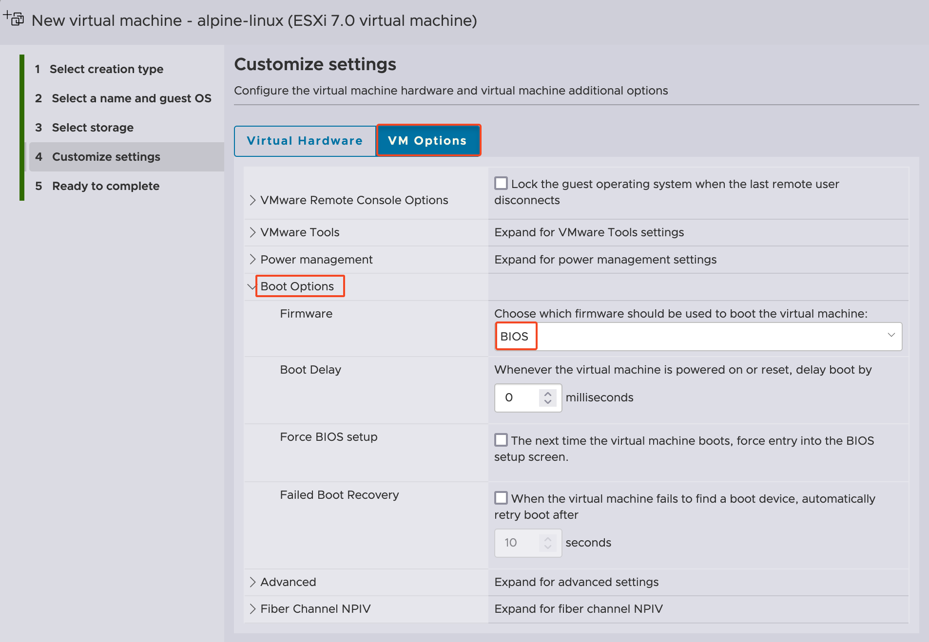
9. Click “NEXT” to review the VM settings. Click “FINISH”.  
   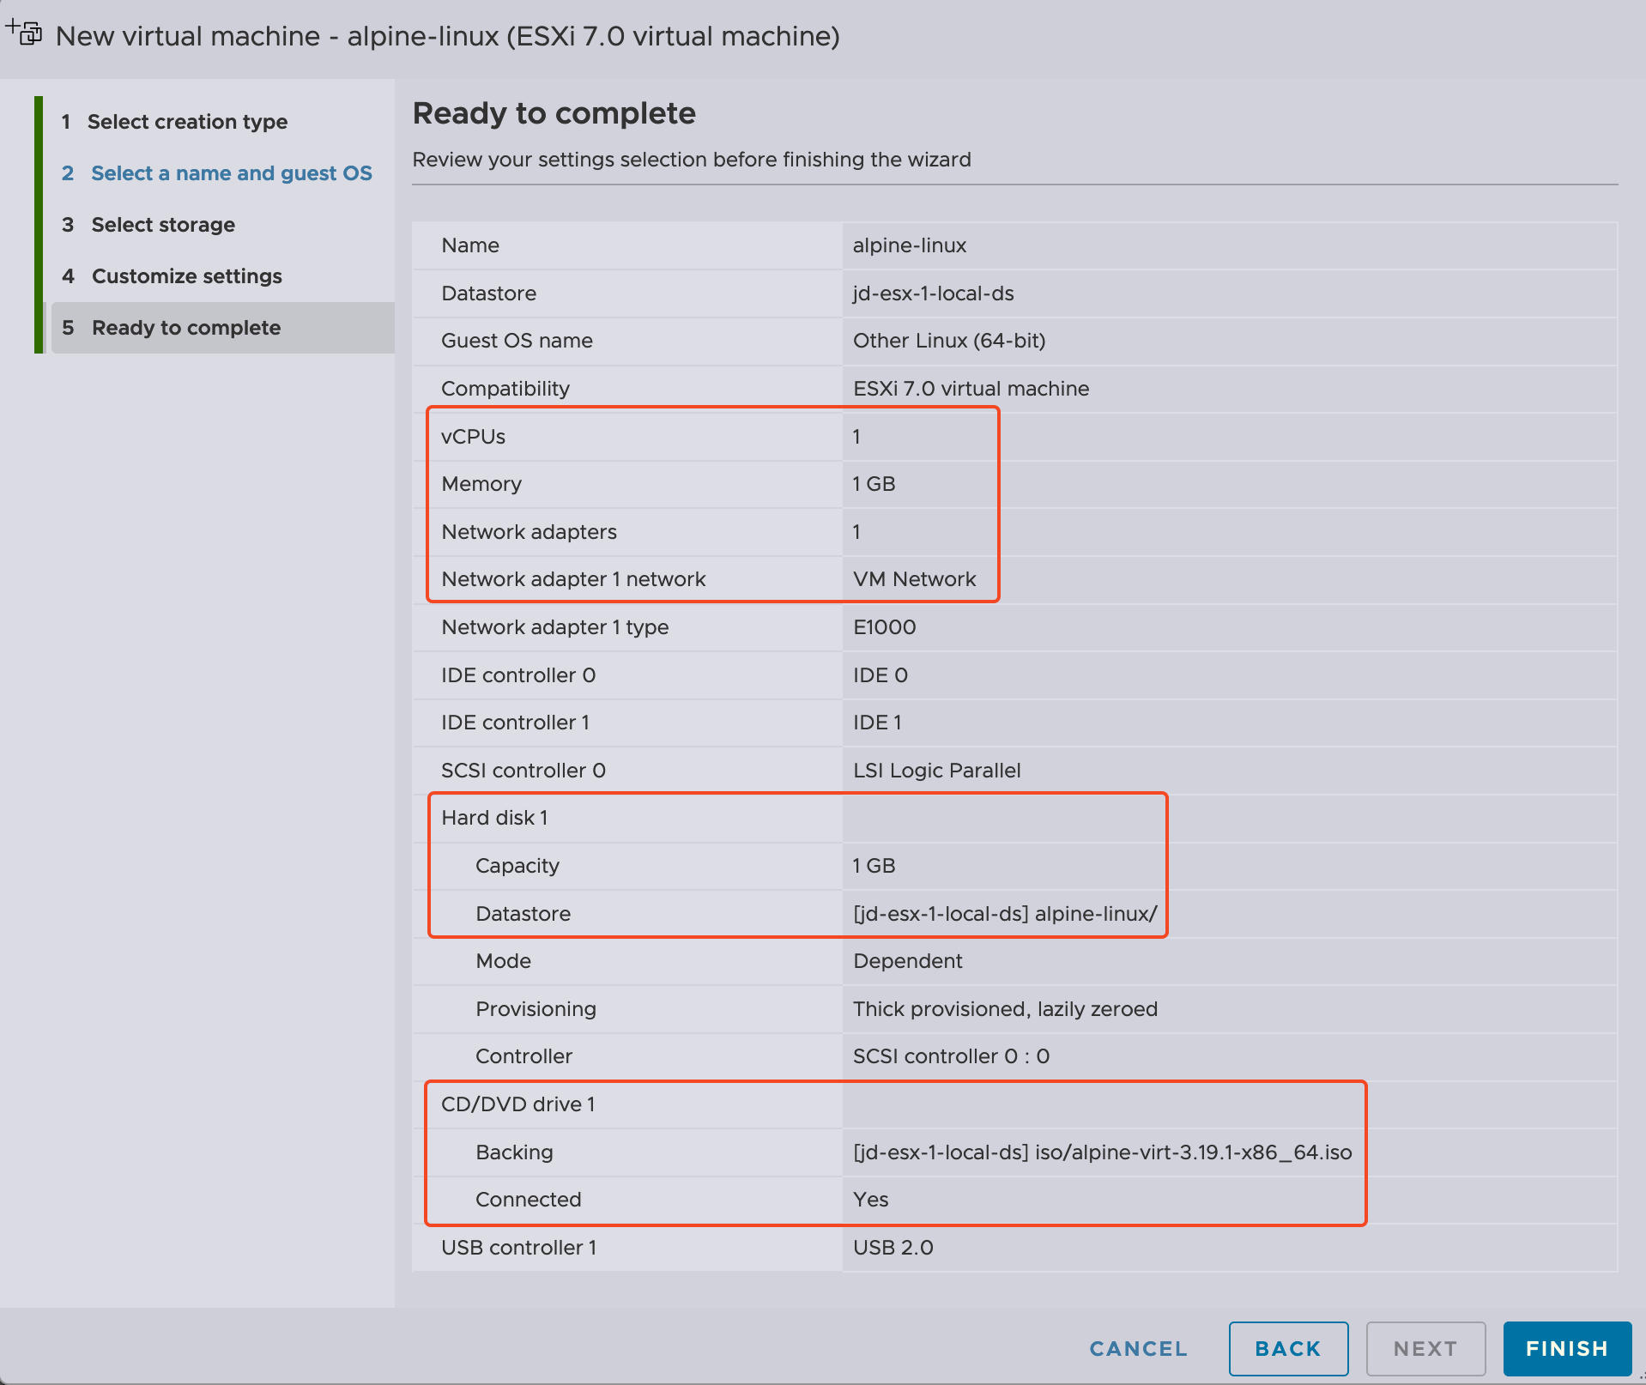
10. The actual installation of the OS will differ depending on the OS you choose. However, you can easily begin the installation in ESXi Host Client. To begin, click “Virtual Machines” from the “Navigator” pane on the left. Then click the VM on which you wish to install an OS.  
    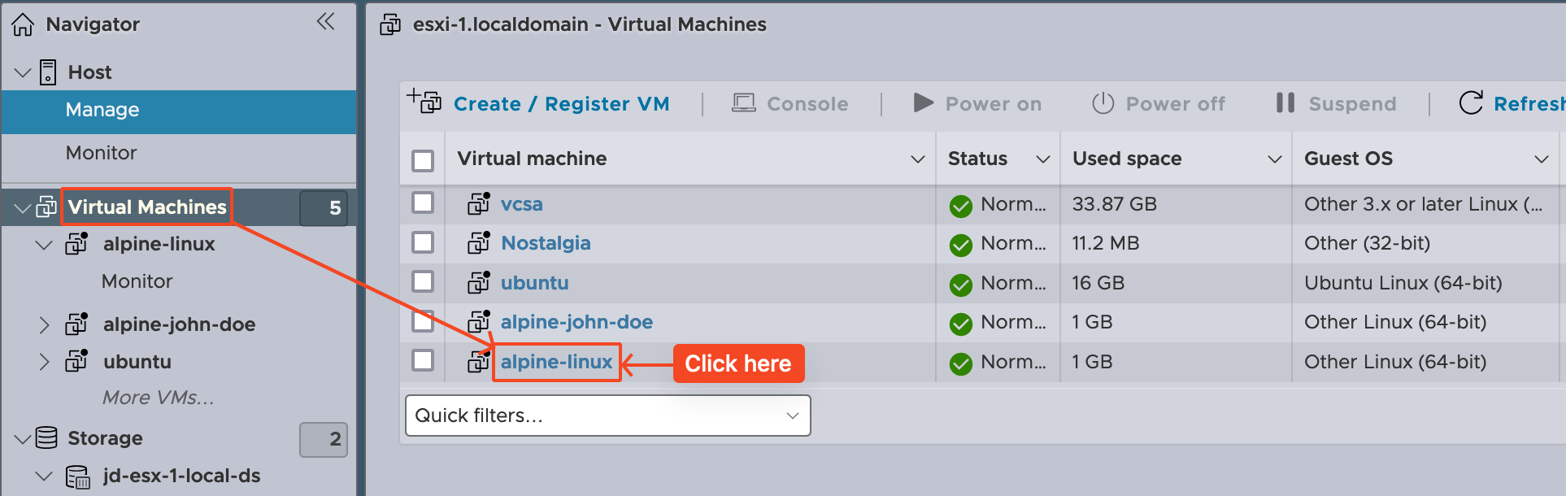
11. Click the “Power on button” (as seen in the following screenshot) and proceed to follow your operating system's installation instructions.  
    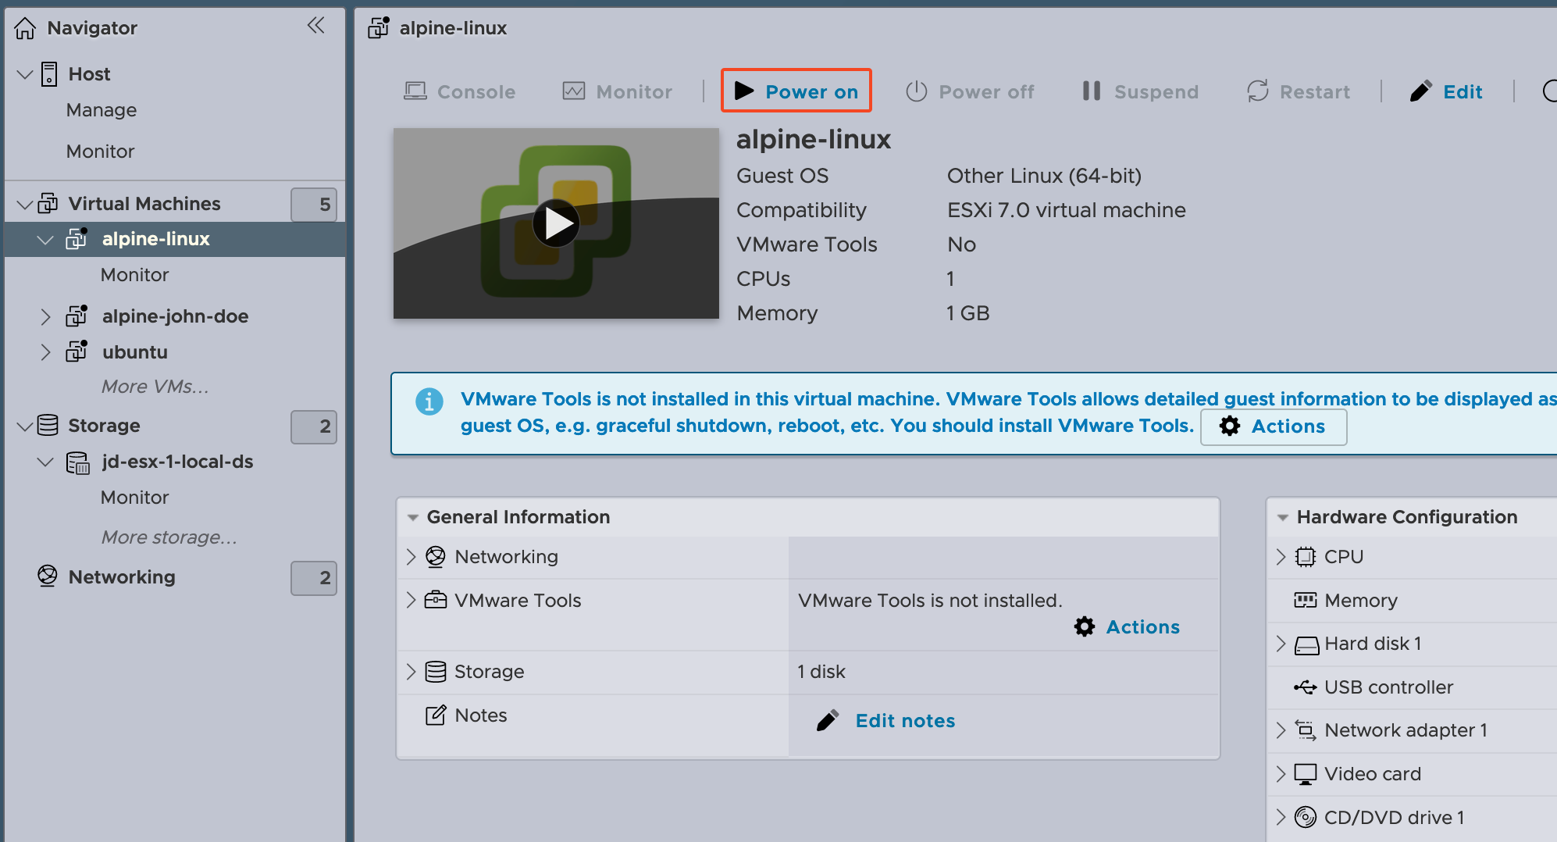
12. Click “Console” button to select “Open browser console”. It’s similar to VMware Workstation’s VM console.  
    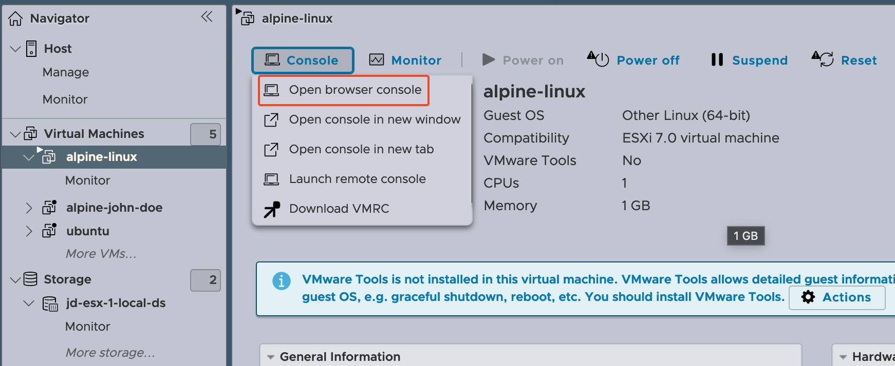
13. The VM will boot a basic command line environment and prompt you for a username. Enter “root”. You will then be sent to the shell.  
    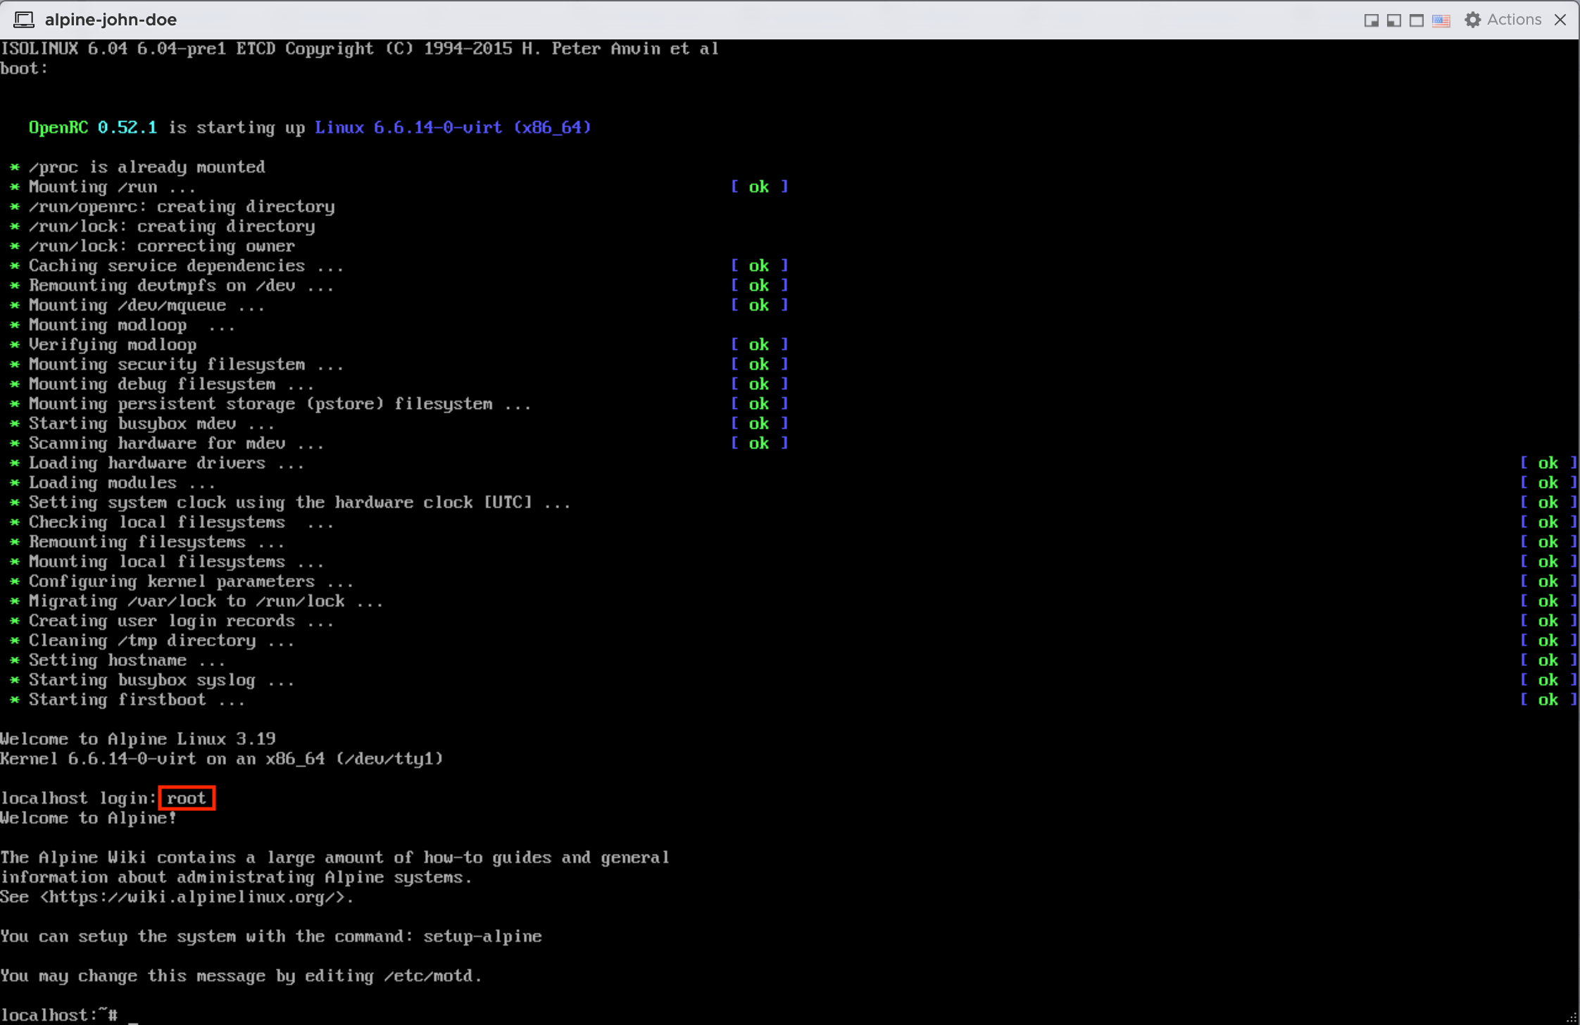
14. Enter “setup-alpine” to being installing Alpine Linux to the vm.  
    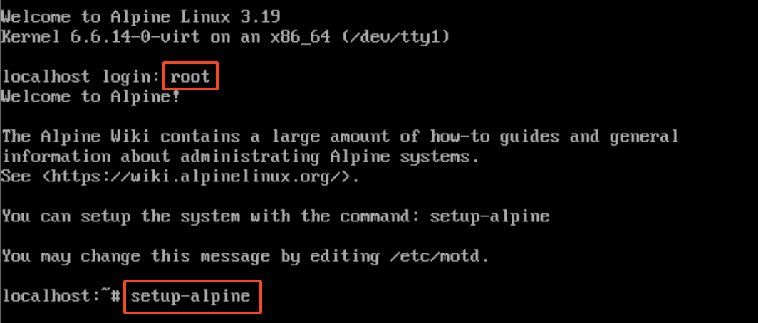
15. For keymap, press ENTER key to use the default value “none”. Use alpine-YOUR_FIRST_NAME-1 as hostname. Use default values for Interface settings.  
    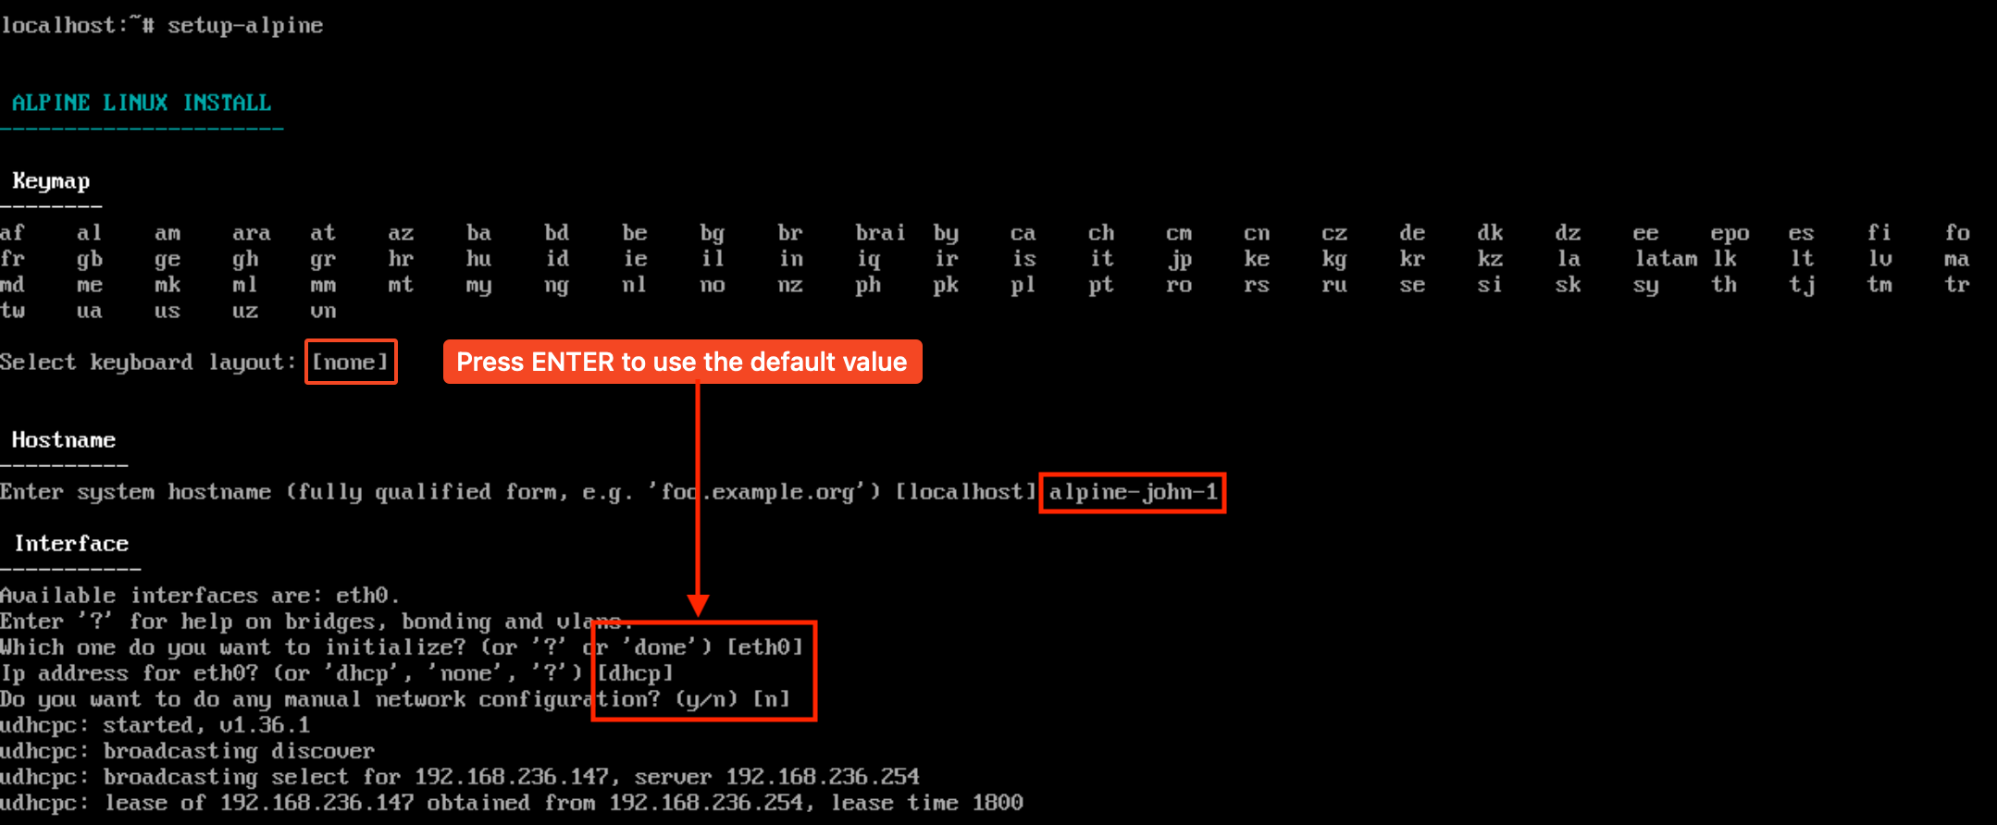
16. Select a secure password for root account. Use “MST” for Timezone. Use default values for Proxy and Network Time Protocol.  
    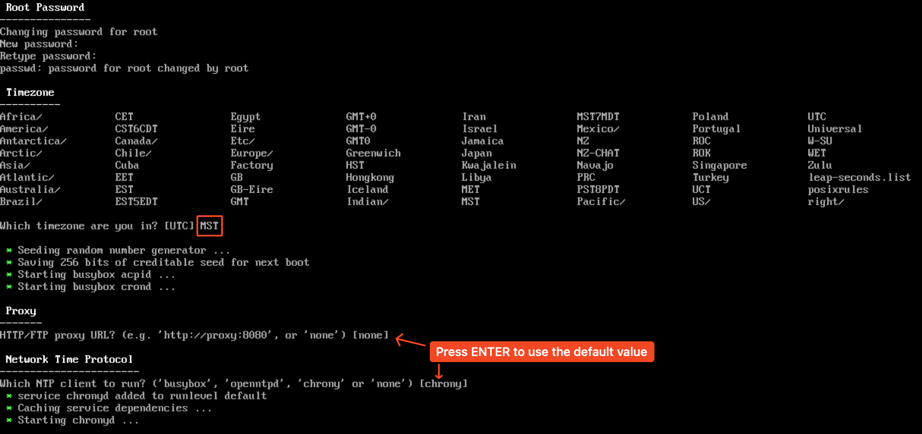
17. Type “r” to use random mirror for APK Mirror or press ENTER for the first mirror. Use all default values for User settings.  
    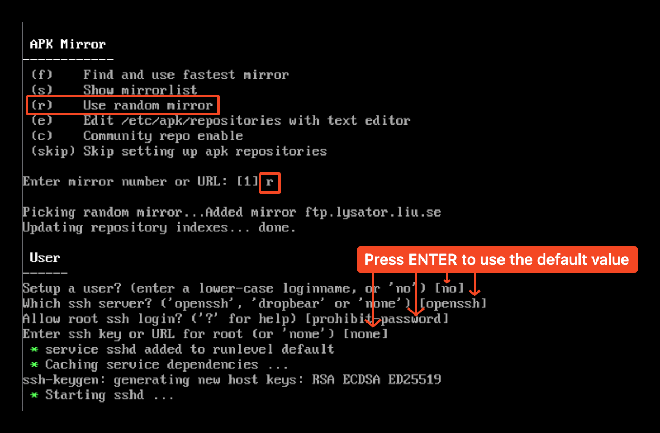
18. **Important**: **DO NOT USE ANY DEFAULT VALUES AND DO NOT MAKE TYPOS** in this step. In Disk & Install settings, answer **sda** to the question “Which disk(s) would you like to use? (or'?' for help or 'none') [none]”. Answer **sys** to the question “How would you like to use it? ('sys', 'data', 'crypt', 'lvm' or '?' for help) [?]”. Answer **y** to the question “WARNING: Erase the above disk(s) and continue? (y/n) [n]”. Once installation is complete, type **reboot** to reboot the VM.  
    